**CloudFormation – Rollbacks**

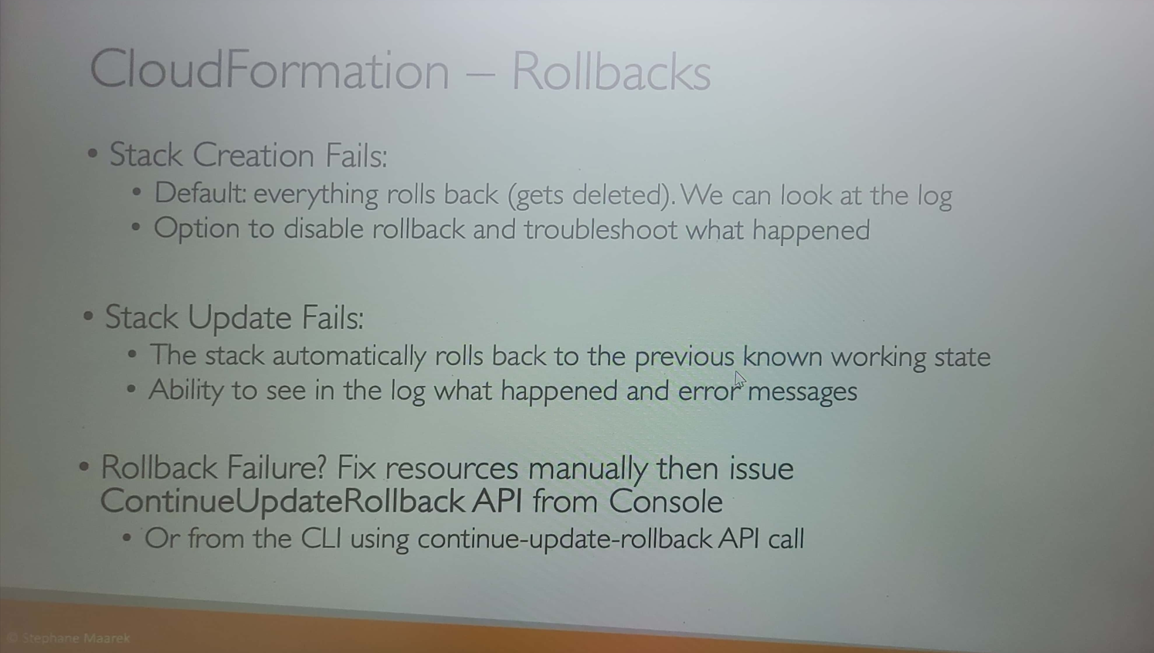

In case of stack creation failures, we have two option either to rollback all the resources or to retain the successfully created resources and delete the unsuccessful ones.

In the below example, even if the “ServerSecurityGroup” was not able to be successfully created but the SSHSecurityGroup has been successfully created.

In the below image, the creation of one resource is failed and other is successful. Now if we want we can delete both by clicking the “Delete” button manually. But if the Rollback is selected while creation then all the resources will be deleted as below:

Example: “ServerSecurityGroup” and “SSHSecurityGroup” have been successfully created but the “FailureOnUpdate” got failed and so everything is rolled back.

The resource creation fails due to incorrect ImageId:

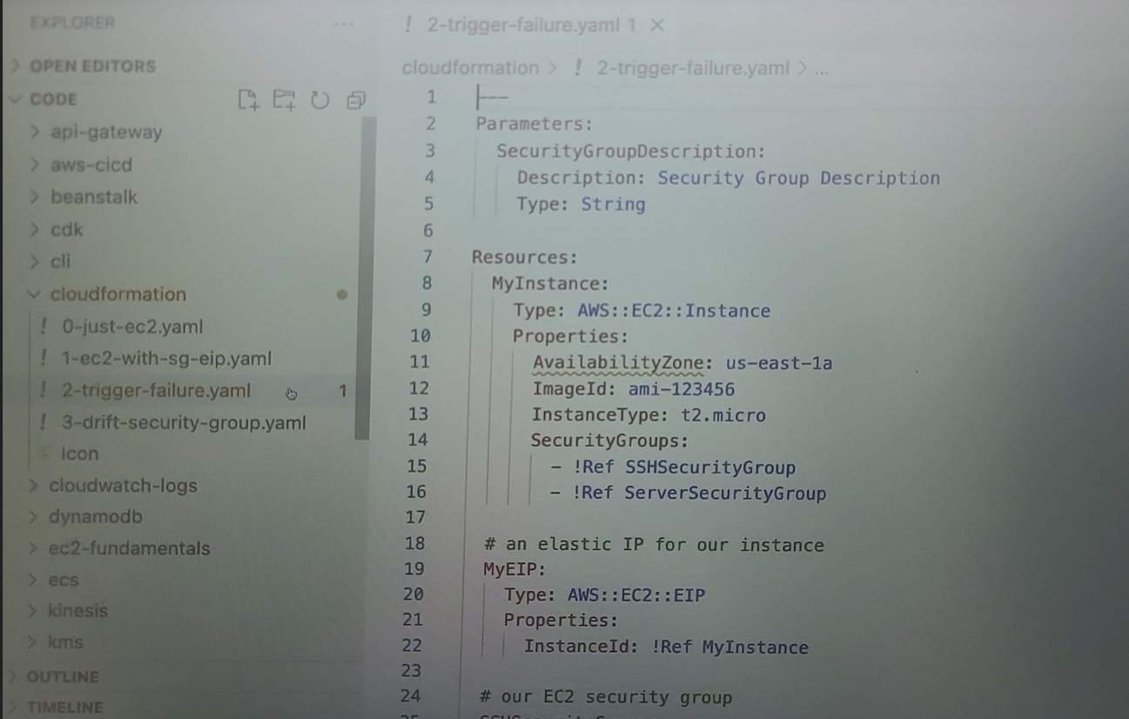

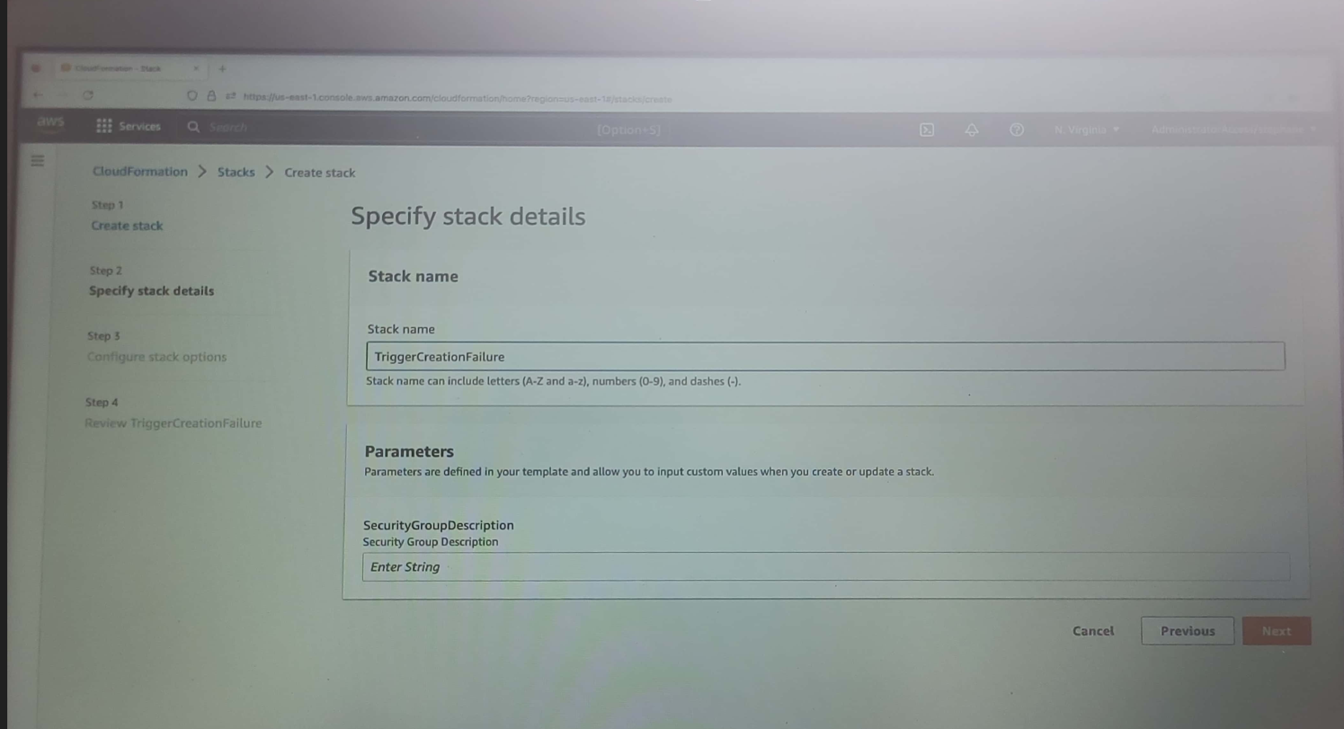

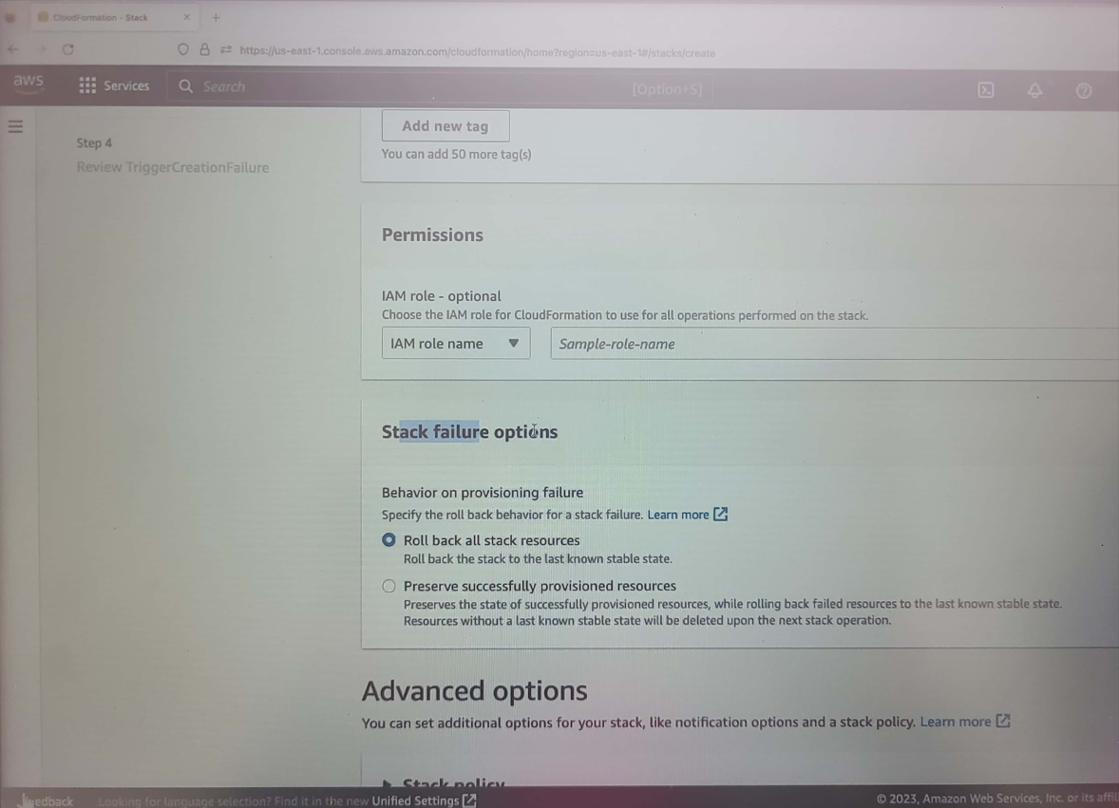

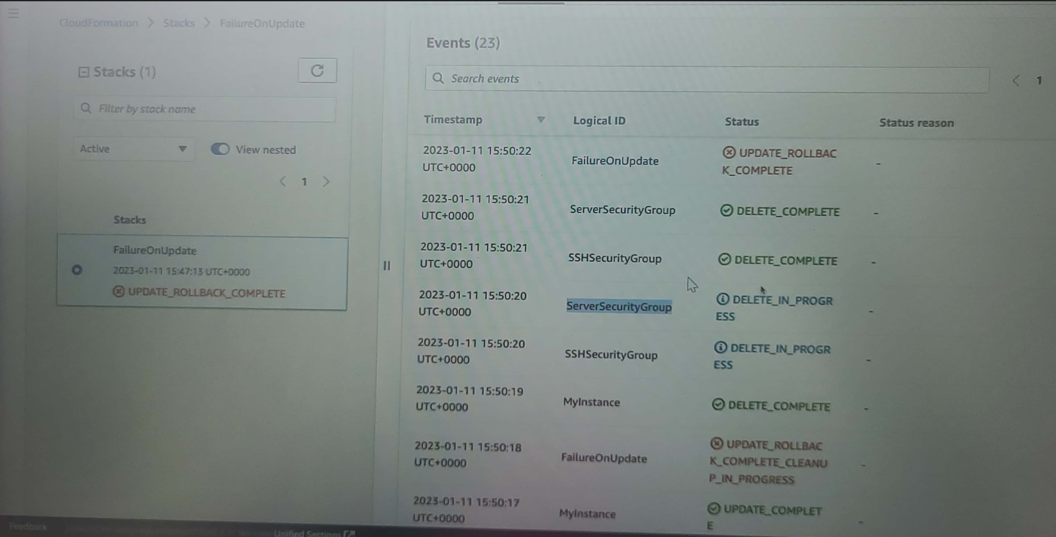

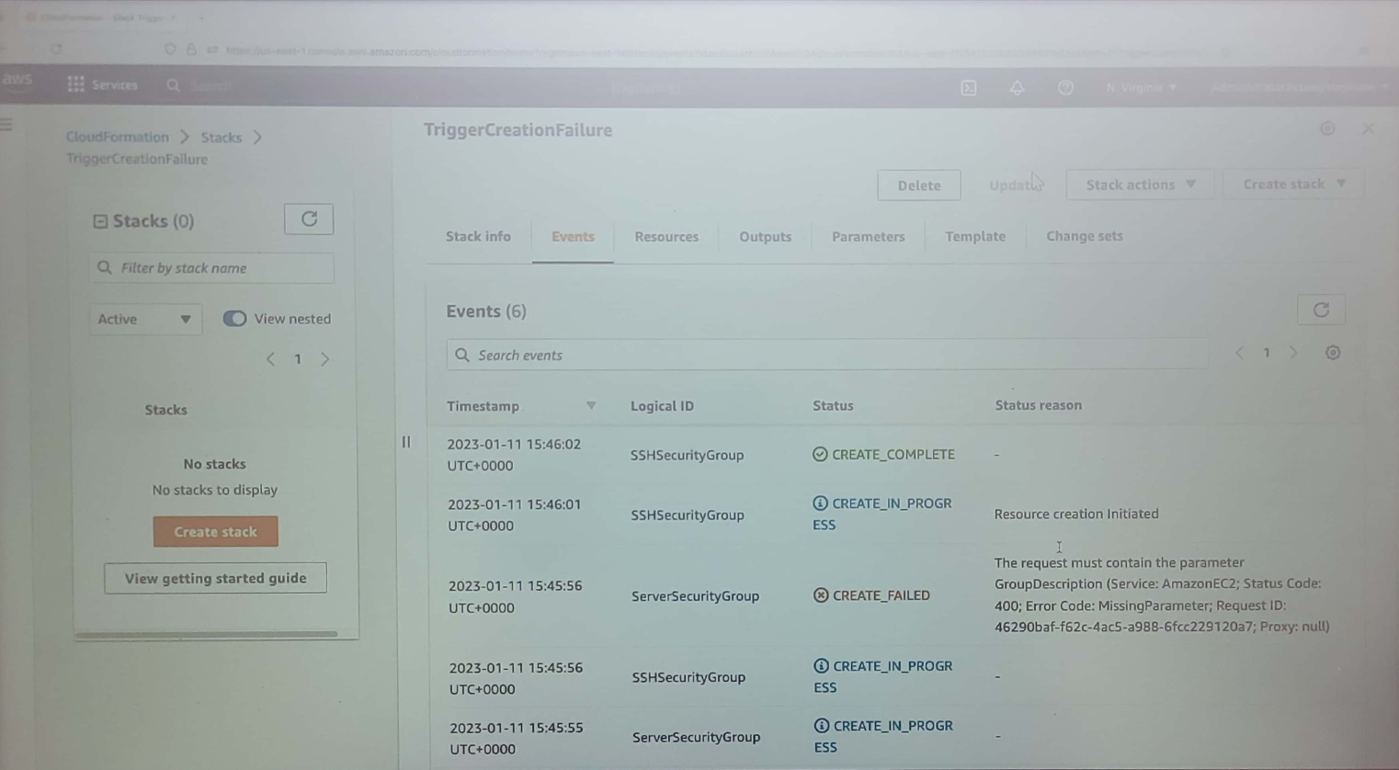

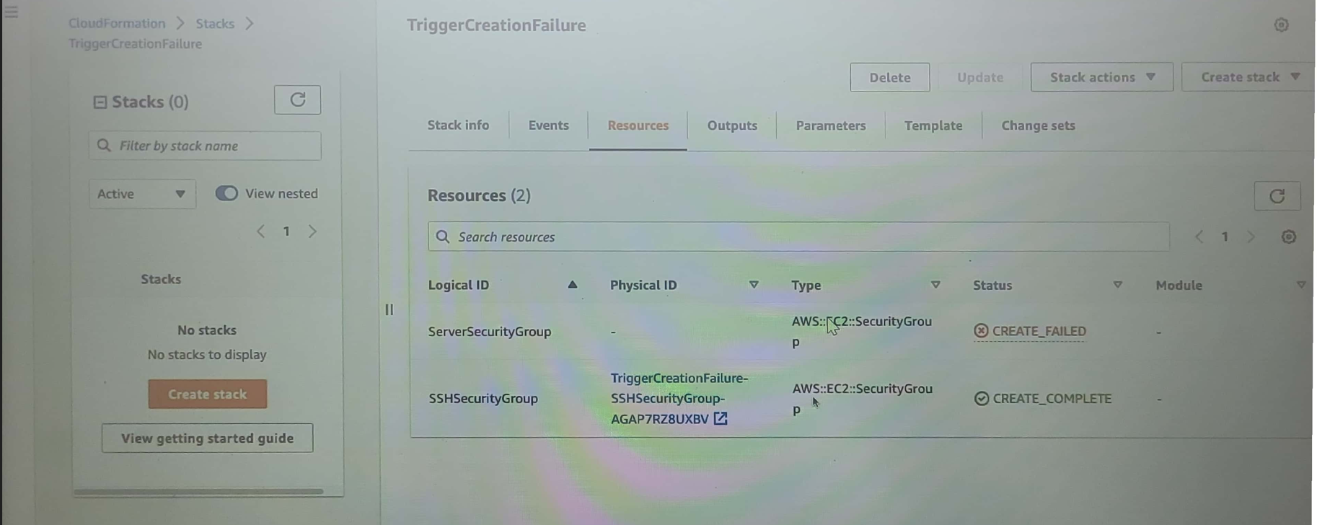

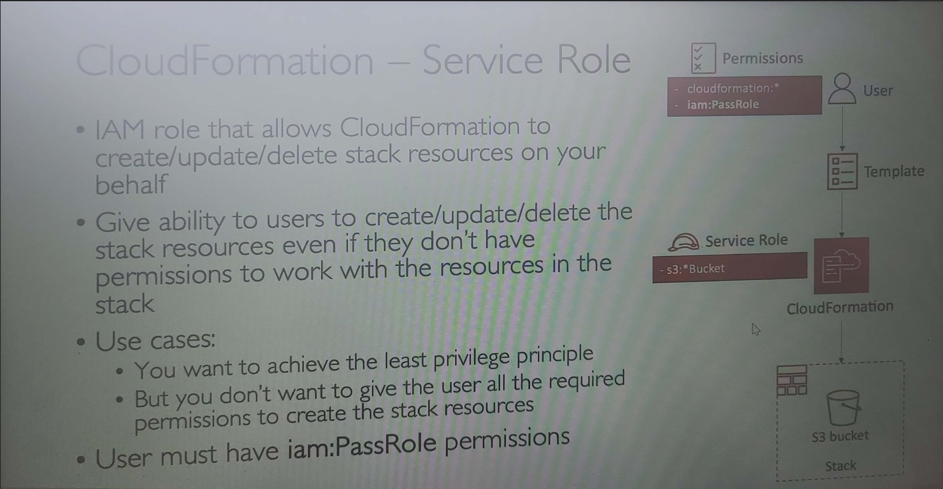

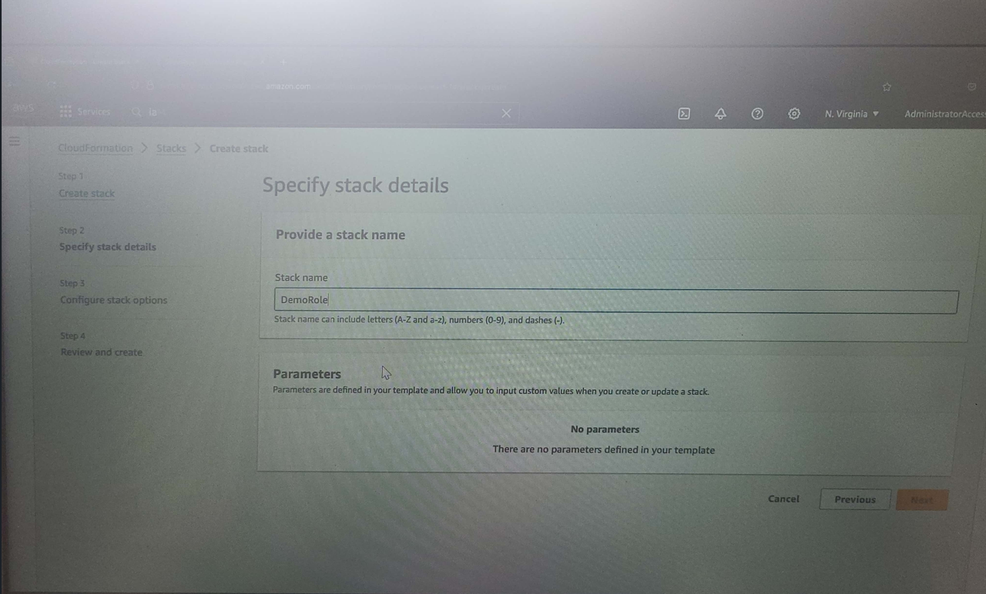

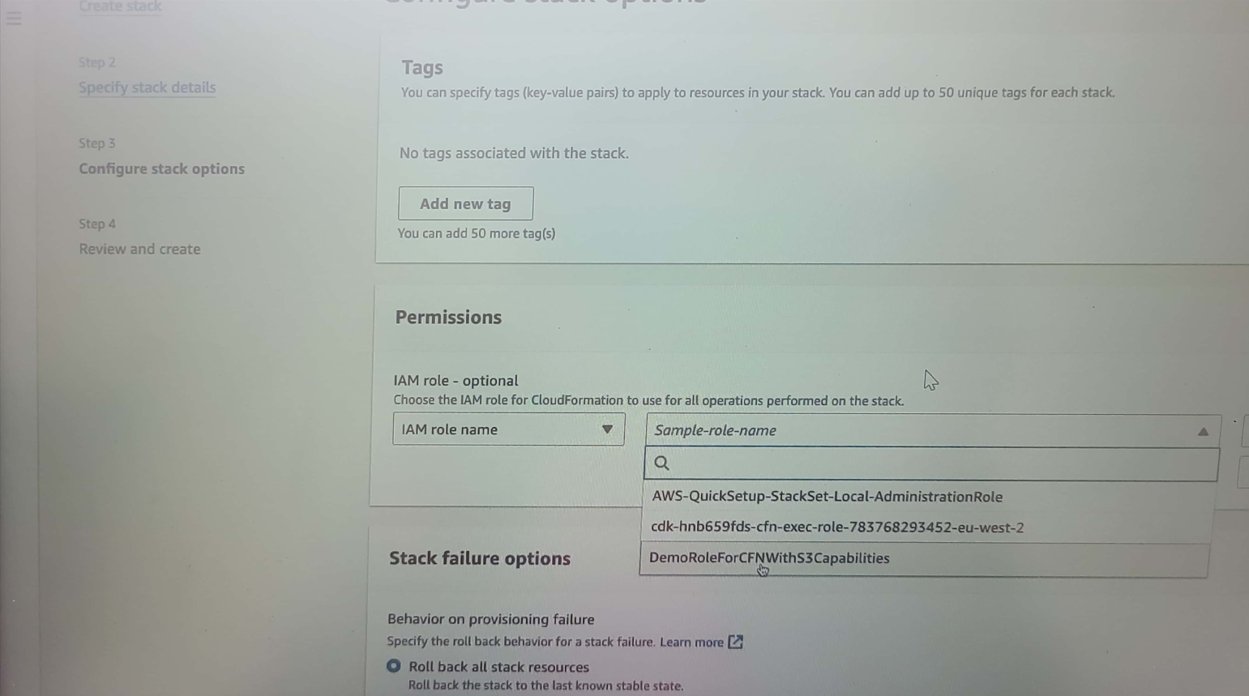

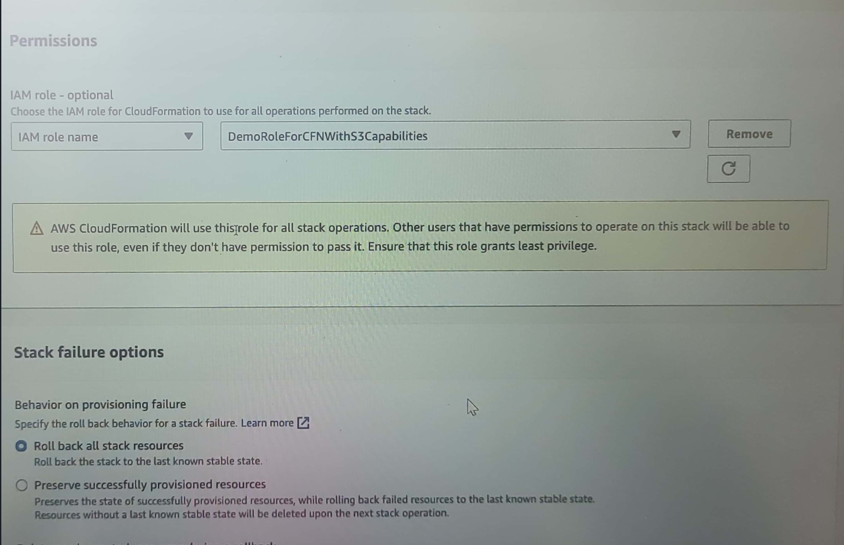

**IAM Role Creation**

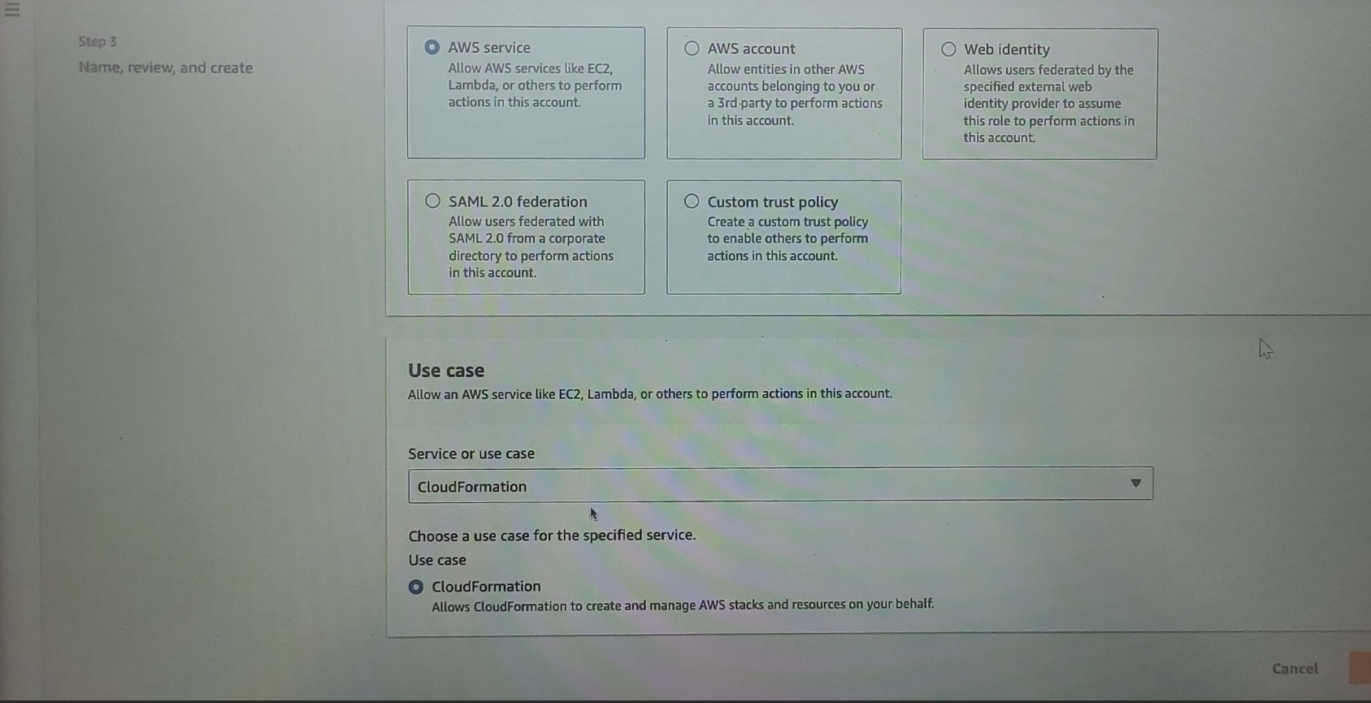

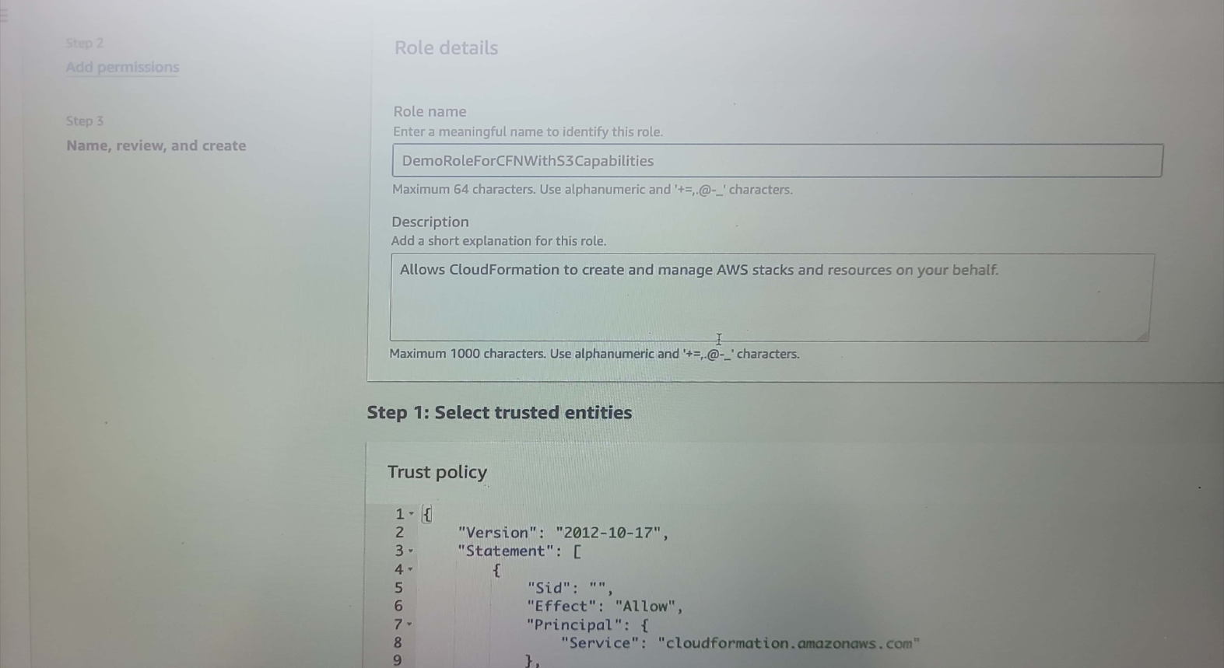

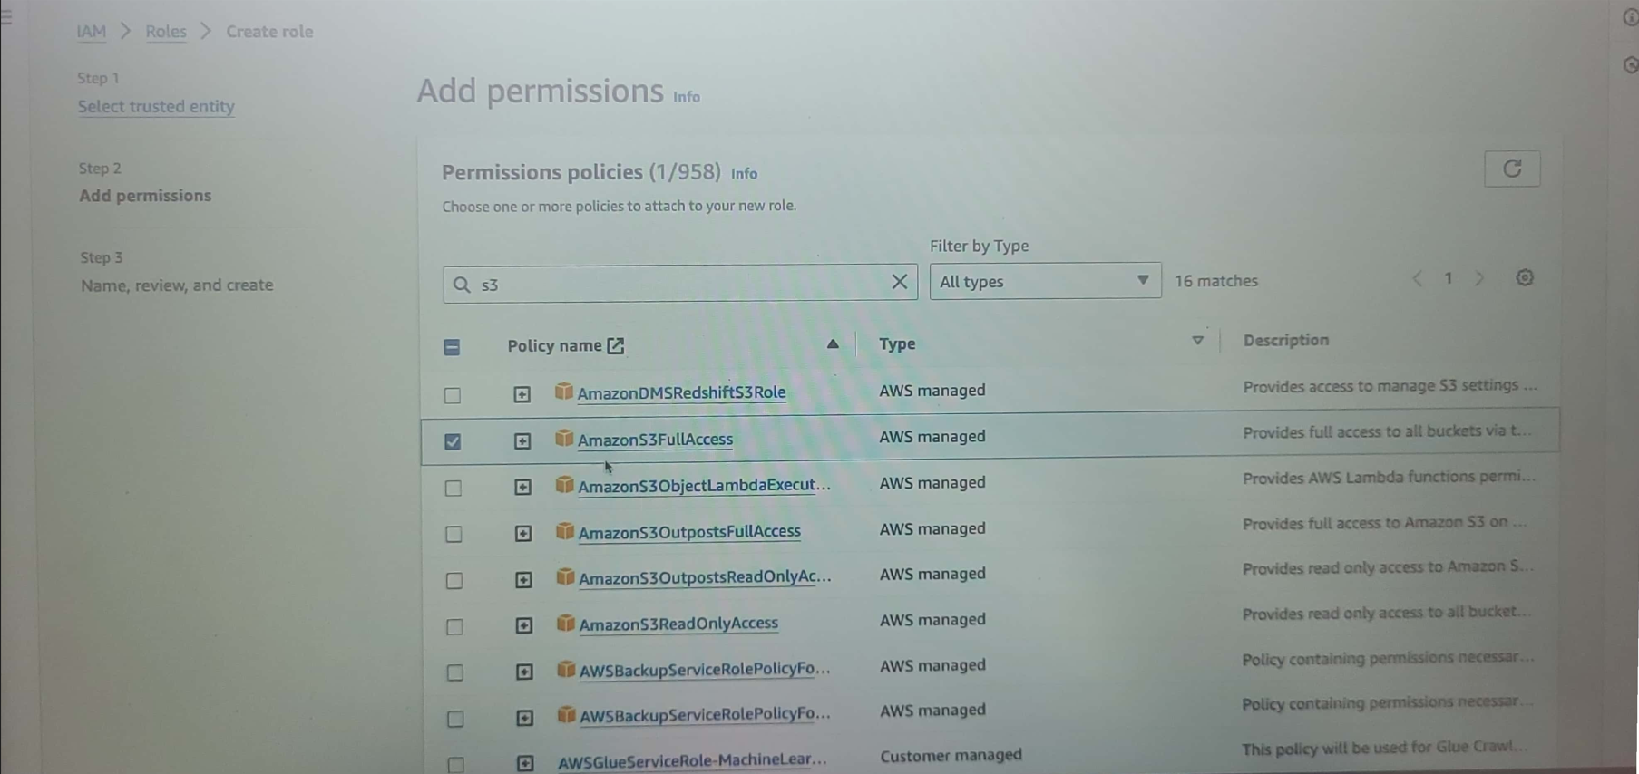

**CloudFormation – Capabilities**

In the below example IAM role(MyCustomRoleName) is created with the amazon full access

(arn:aws:iam:aws:policy/AmazonEC2FullAccess)

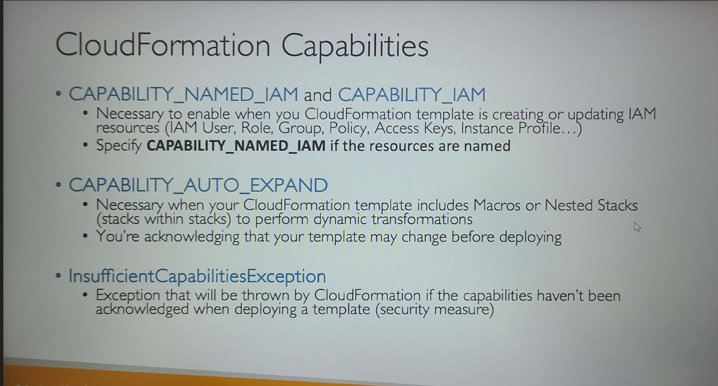

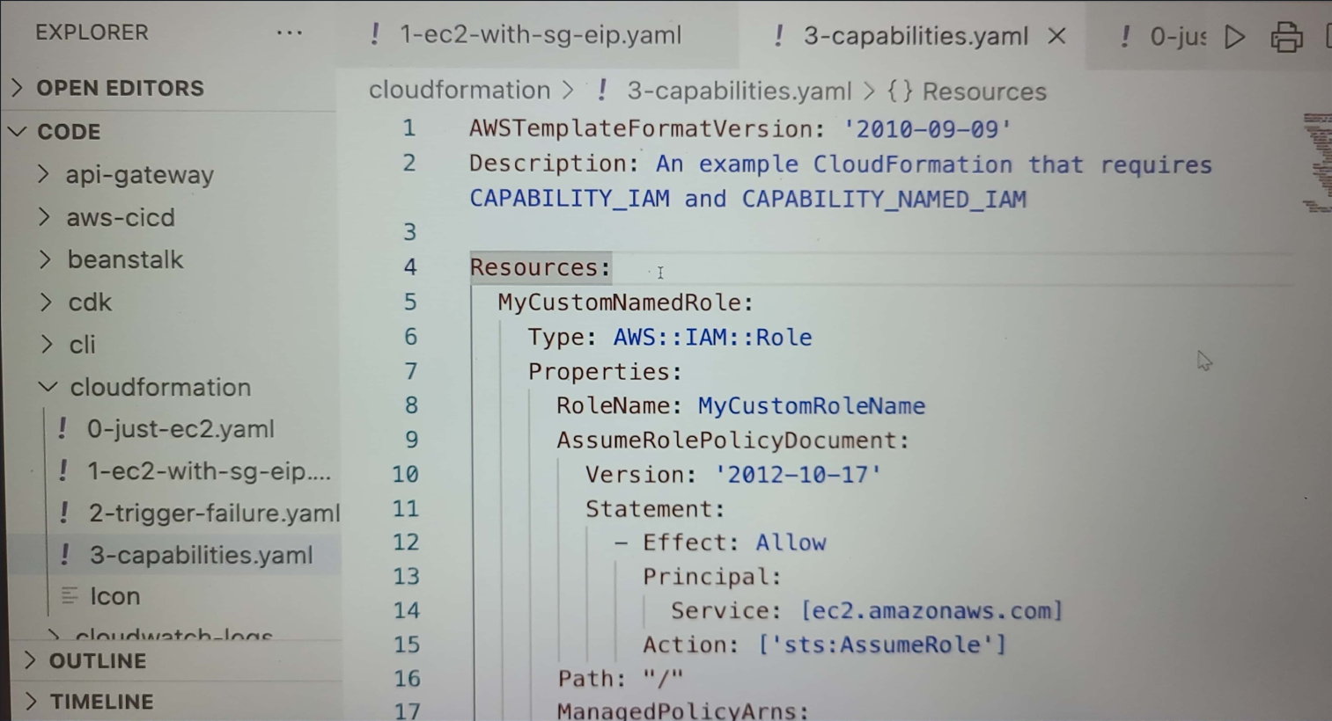

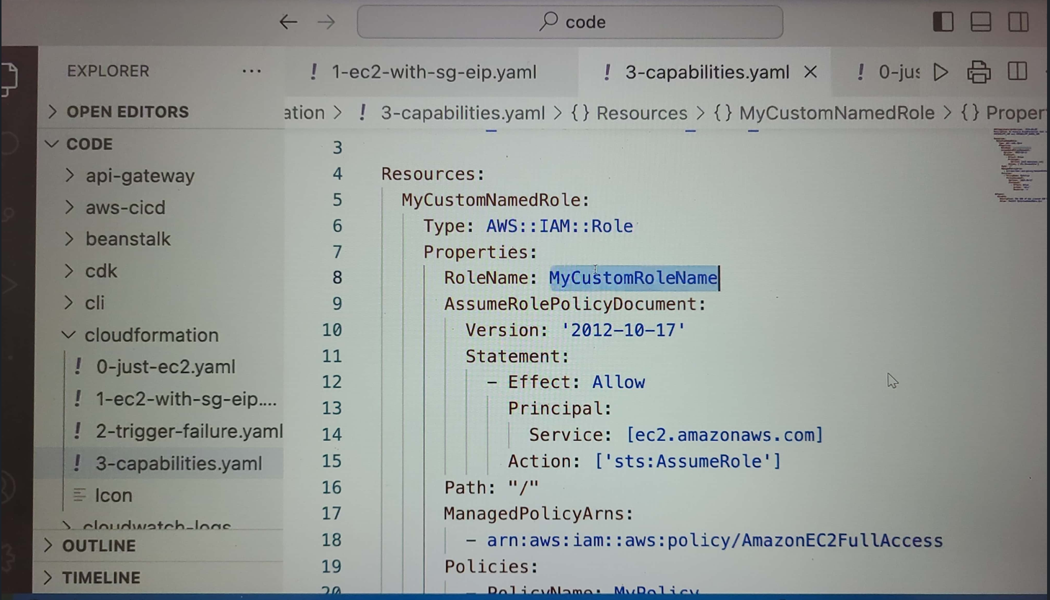

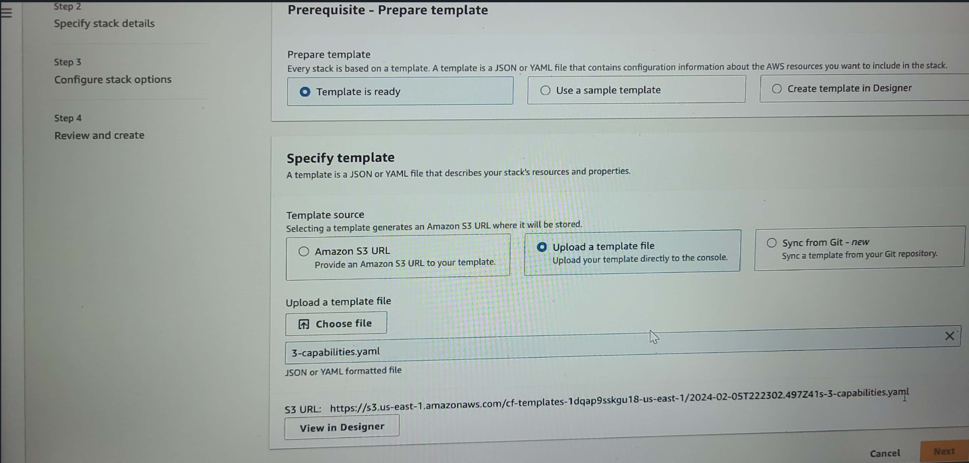

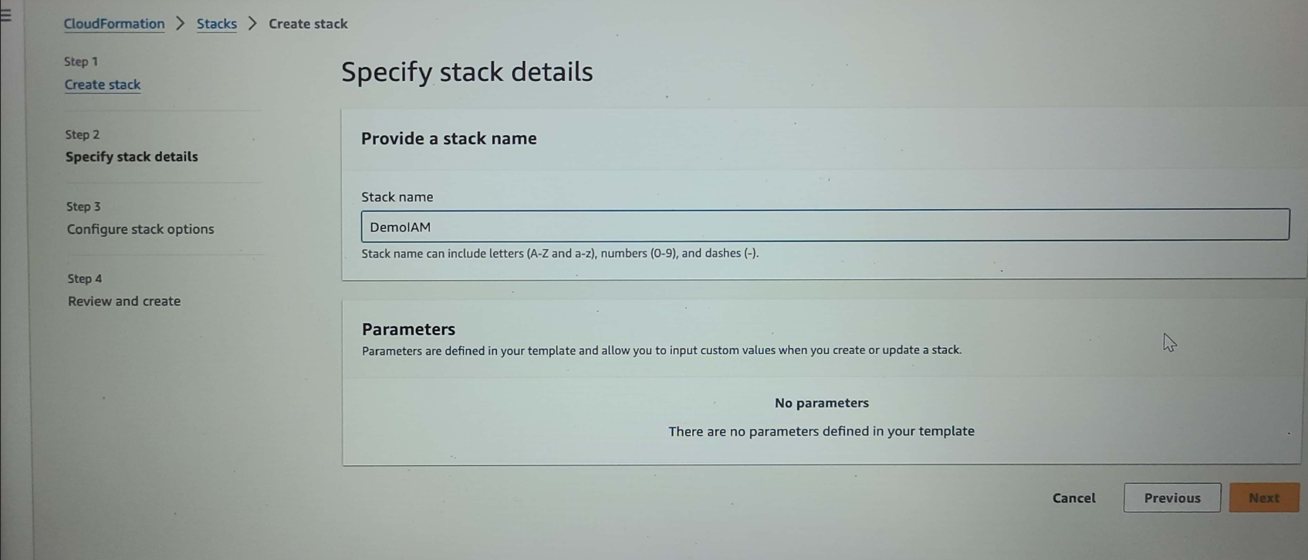

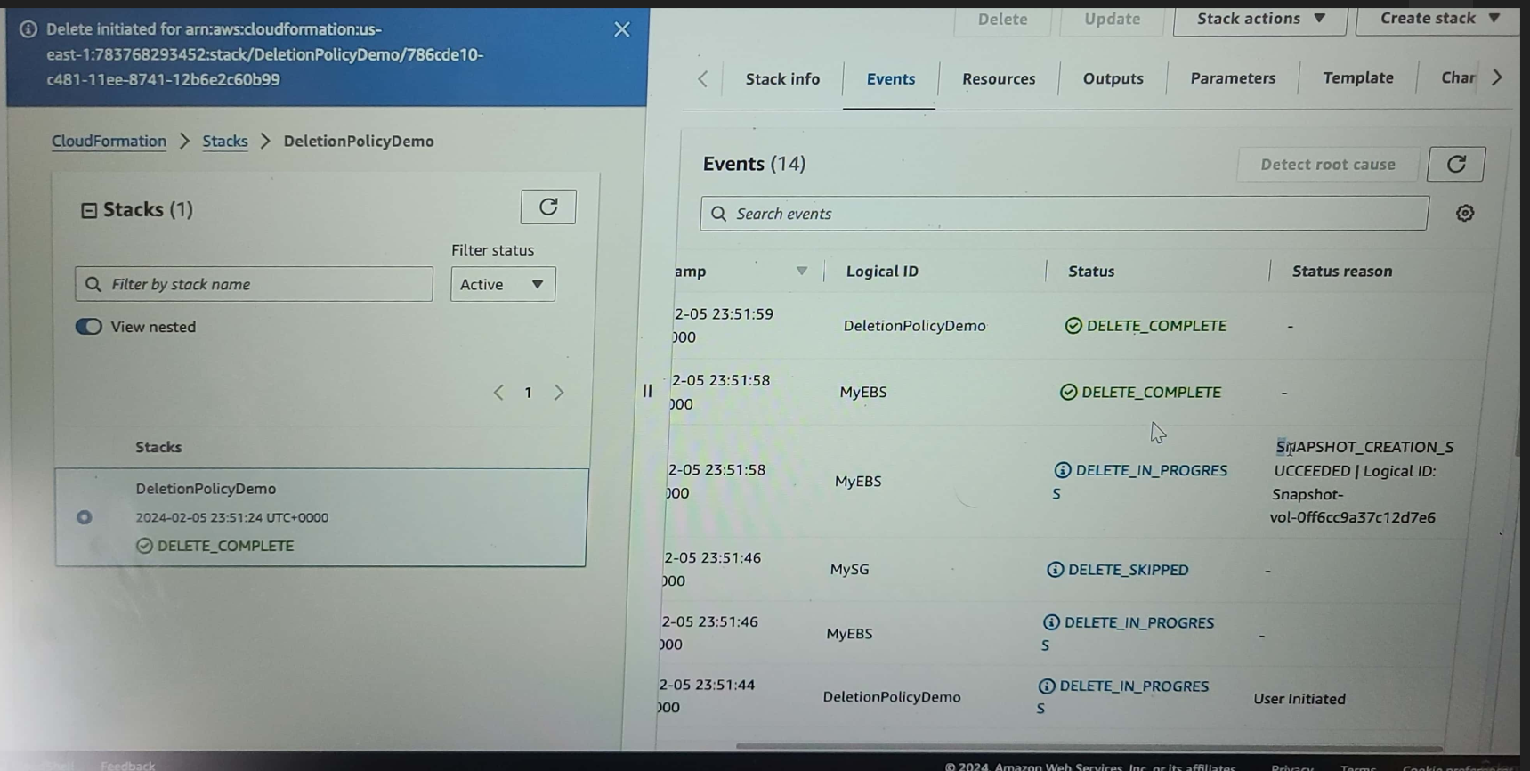

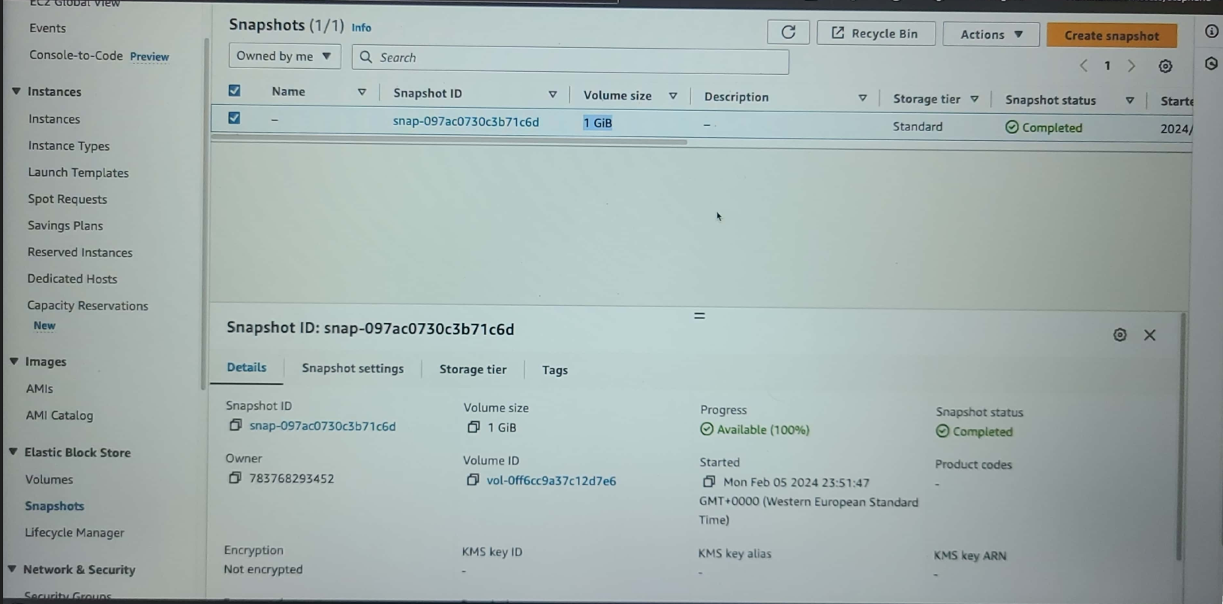

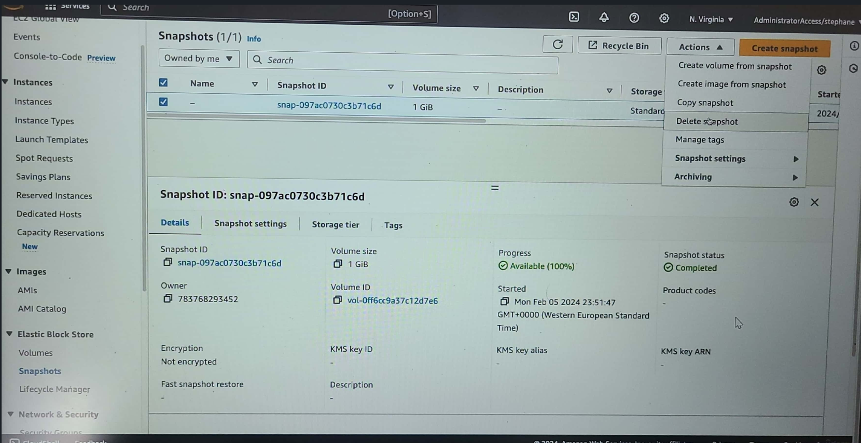

**CloudFormation – DeletionPolicy**

The default policy is “Delete” so no need to explicitly specify it. In case of S3 bucket, the deletion will not work if the bucket has content. We need to manually delete the contents.

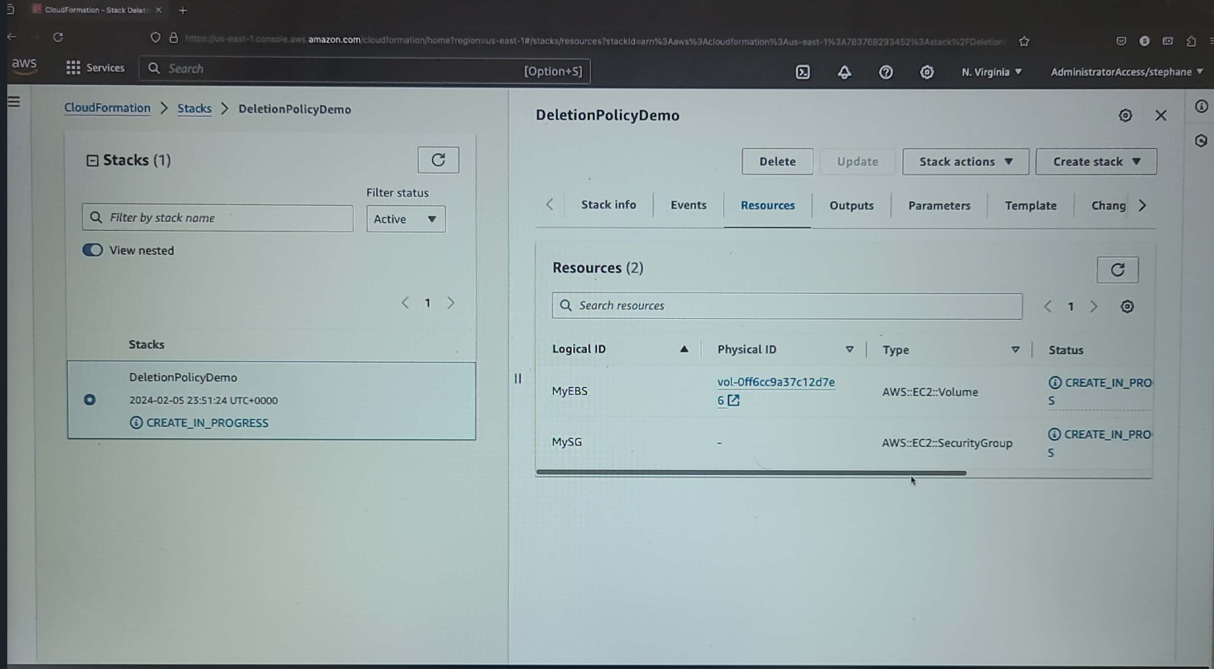

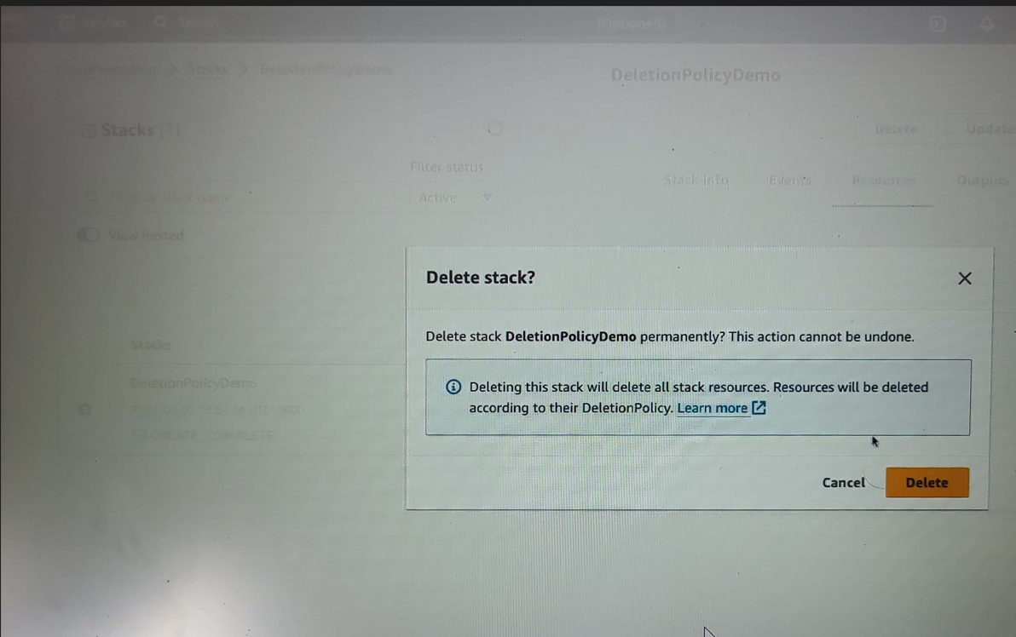



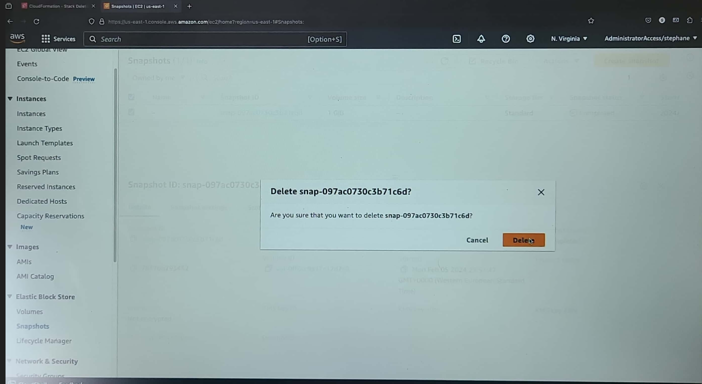

**Lambda**

Lambda services run to the maximum of 15minutes. Lambda responds to events.

Note: As the invocation increases, lambda scaling happens automatically.

*Lambda integrated with*

* API Gateway <- can invoke the Rest API (lambda services)
* Kinesis <- invokes lambda for on the fly calculation
* DynamoDB <- to create triggers whenever any data is updated/created/deleted
* SNS <- to react notifications in SNS Queue
* SQS <- to process messages from SQS queue
* Cognito <- to react whenever a user logs in the database

***CRON Job:***

This is to create a job in EC2 instance which runs at every 5min or every Monday 6am etc depends on our setting.

*The Lambda services need to deployed to expose for that we need to create the target group*

*On clicking the Permission link of “Configuration” tab then we could see the IAM role created by the console for that particular lambda service. On clicking the role name we could get the role details*

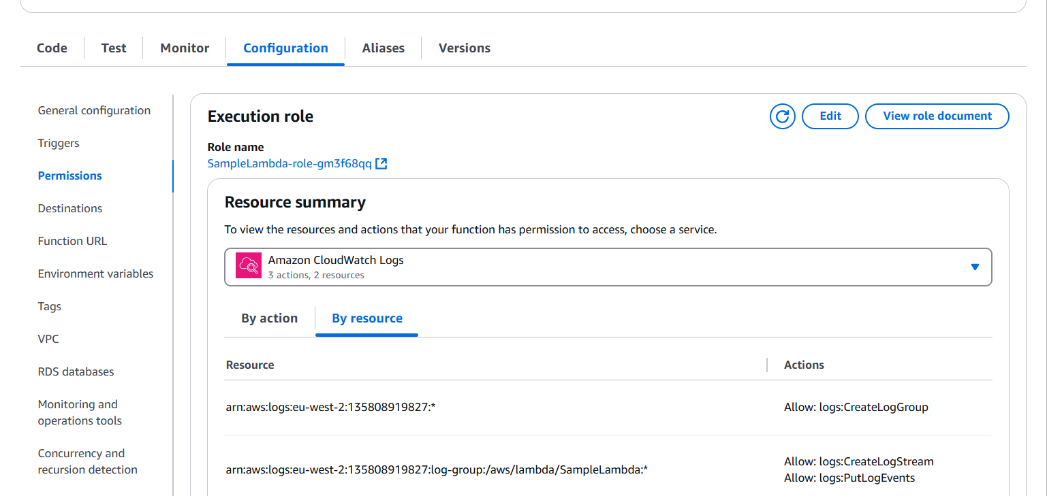

*On clicking the “Monitor” tab we could get the info on the invocations, cloudwatchlogs as well as time taken for execution etc.*

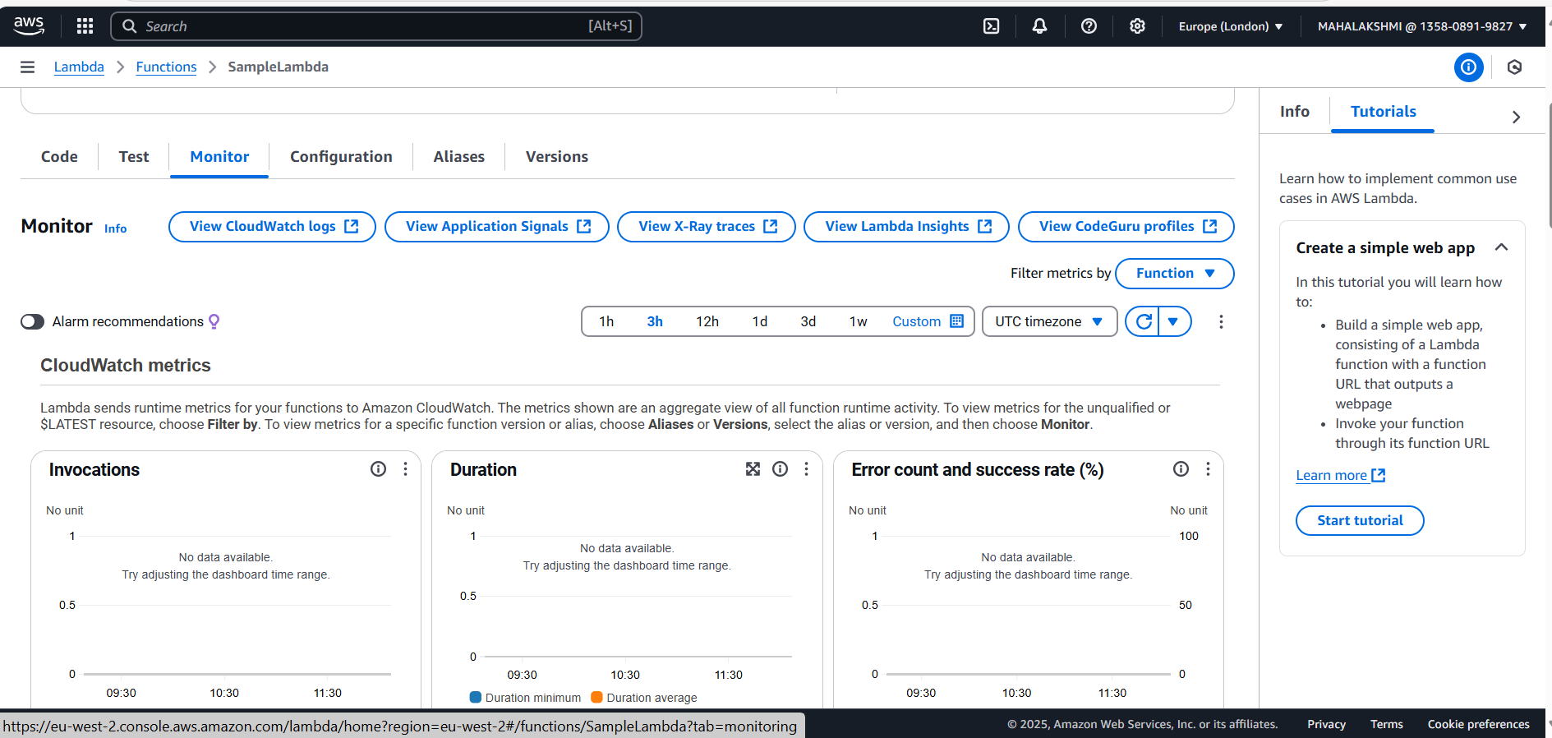

*On clicking the “View CloudWatch Logs”, we could see the log details*

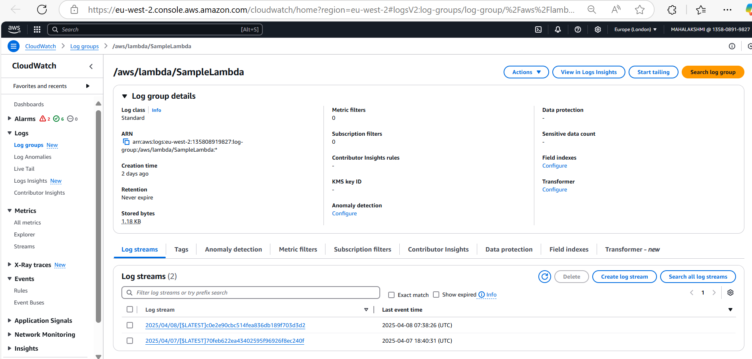

*On clicking the specific log streams then we will be taken to the detailed view:*

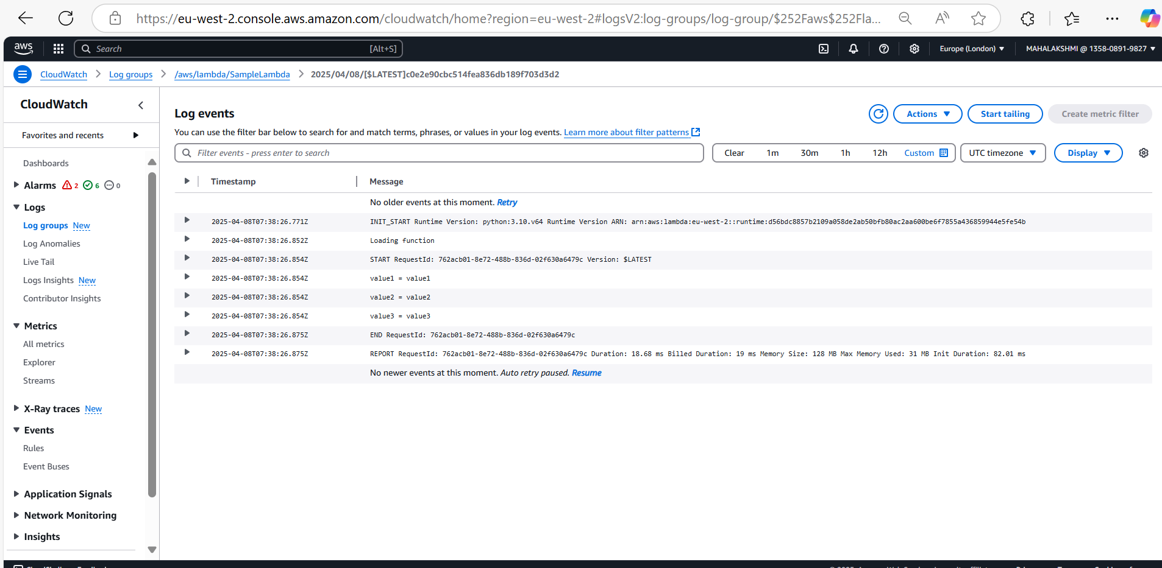

*On clicking the “Test” tab we could test the lambda function after creating the event*

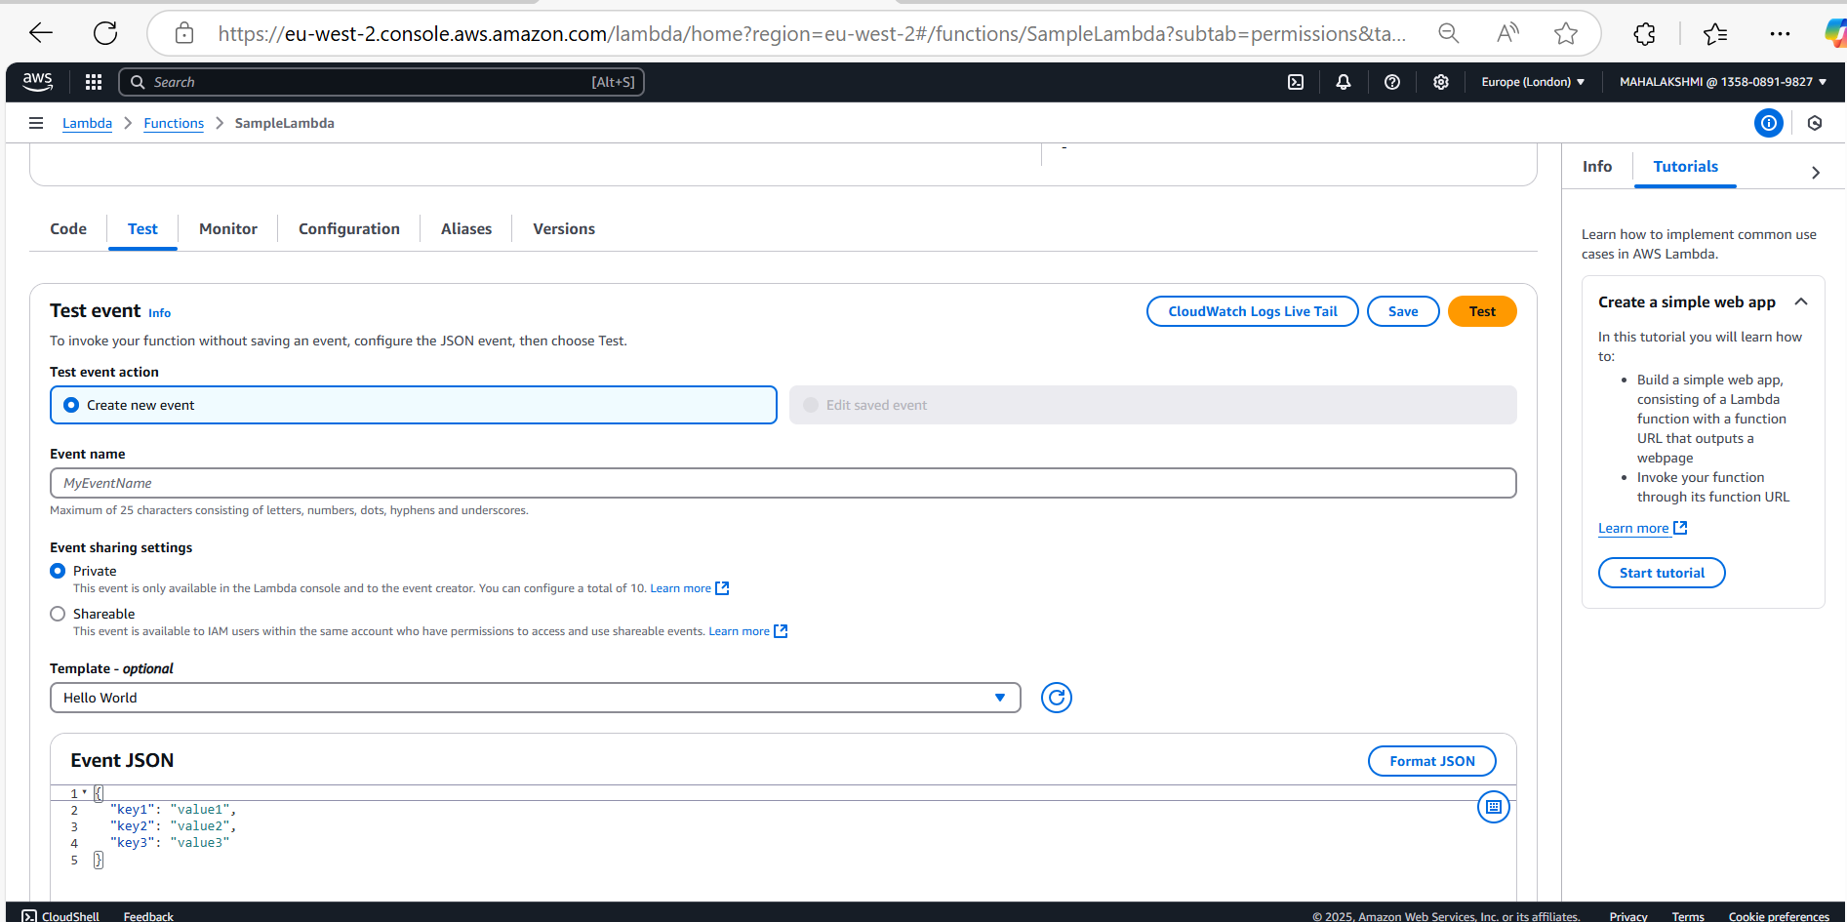

*In order to test the changes, we should deploy the lambda function by clicking the “Deploy” button*

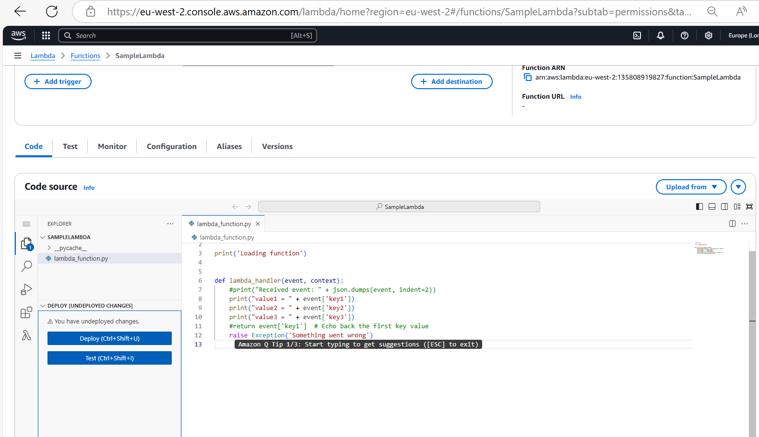

***DynamoDB:***

***Option1 : DynamoDB has primary key called hash key and it should be unique for each item(row)***

***Option2: DynamoDB has primary key + sort key (Hash + Range) here the sort key has to be unique for that hash key***

*In DynamoDB, we can’t create the DB, we can only create the table*

*On clicking the “Create table” we could create the table*

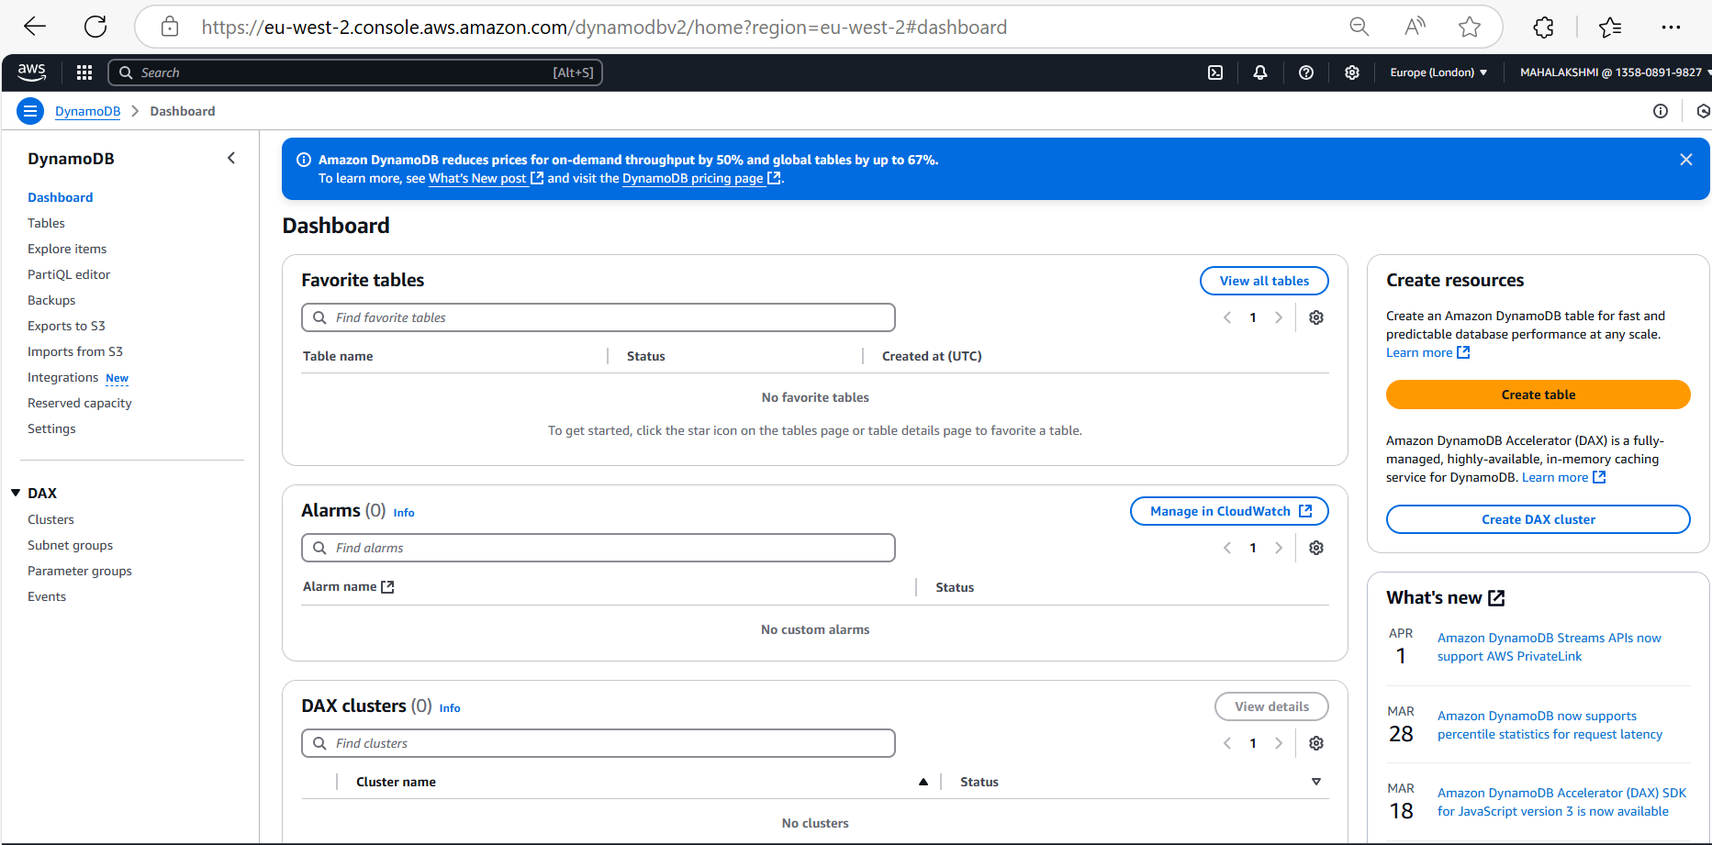

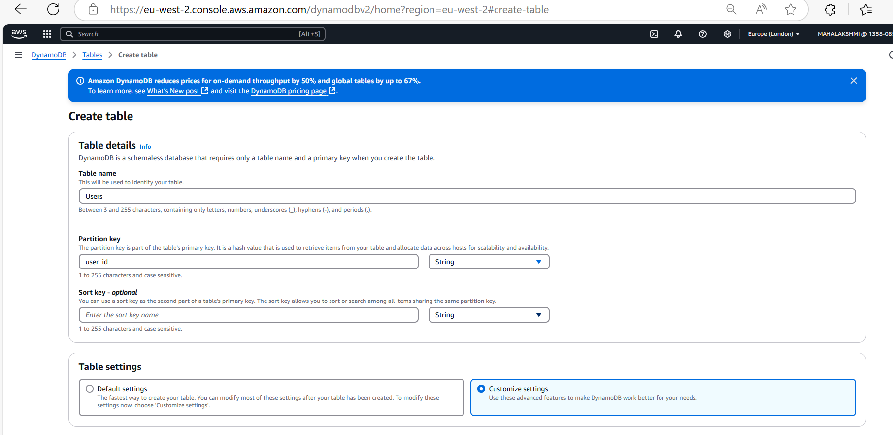

*We have Customize settings to modify the table settings and in the table class we should choose “DynamoDB Standard-IA” if the data is frequently updated or accessed otherwise choose “DynamoDB Standard”*

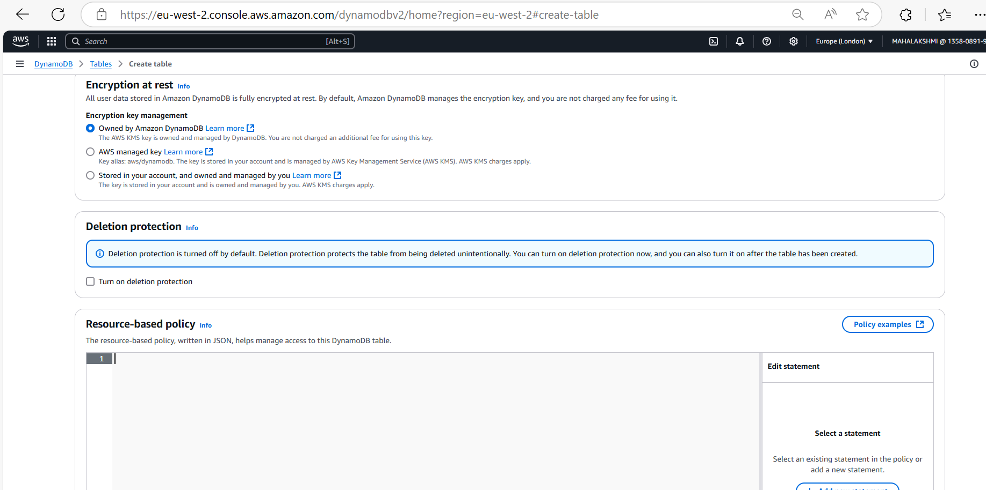

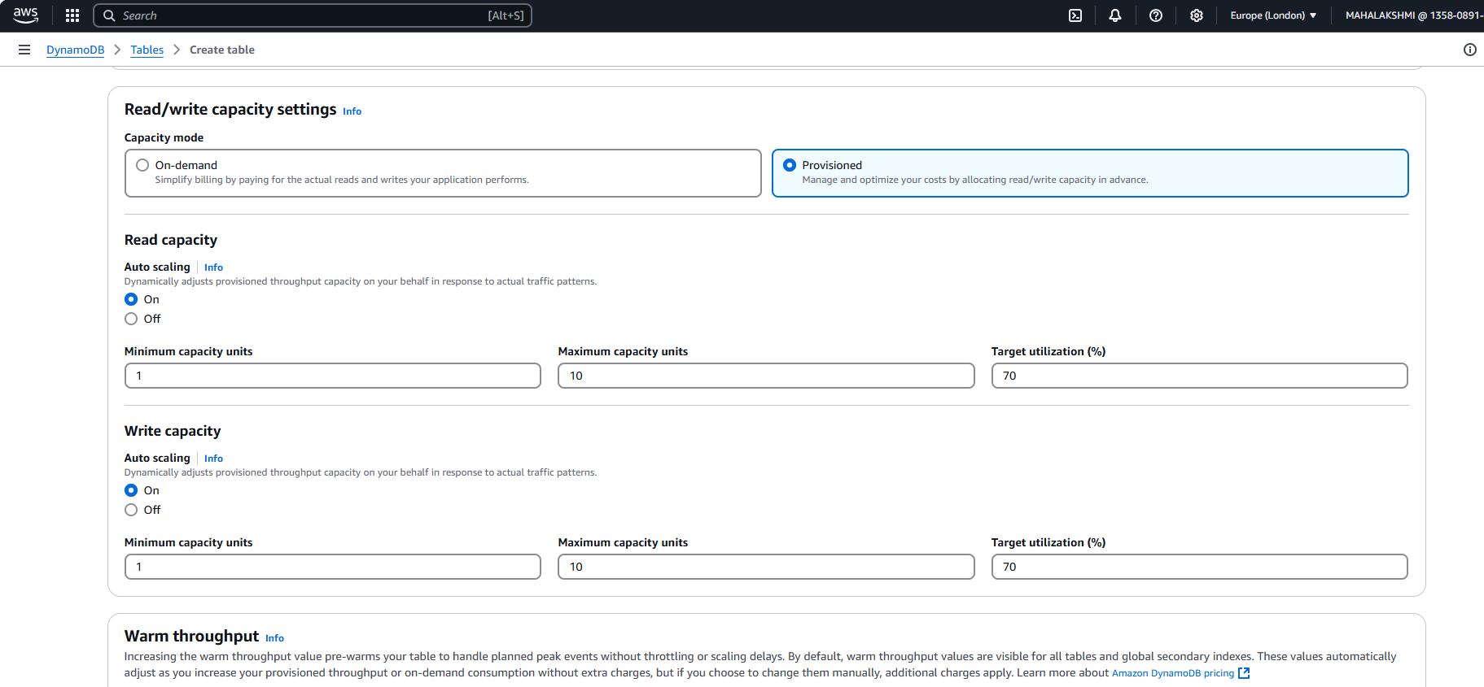

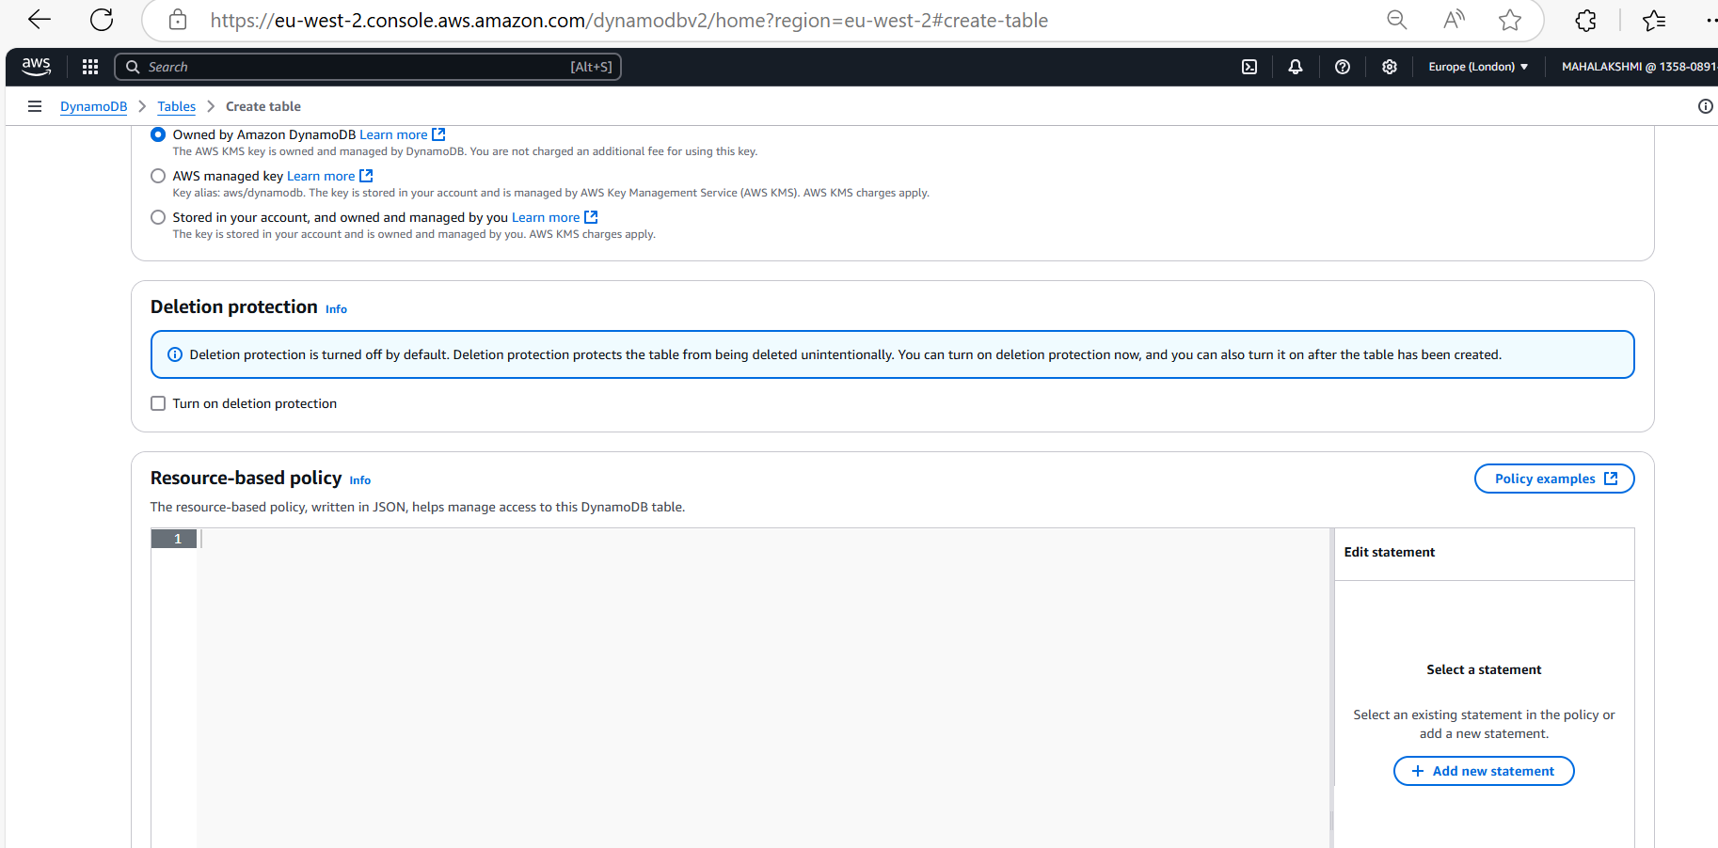

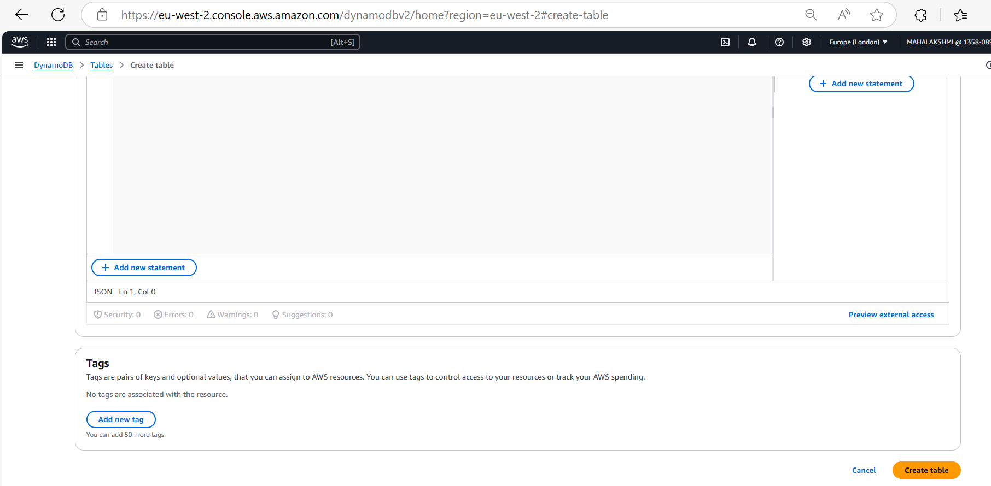

*On clicking the created table we could get lot of information of the table*

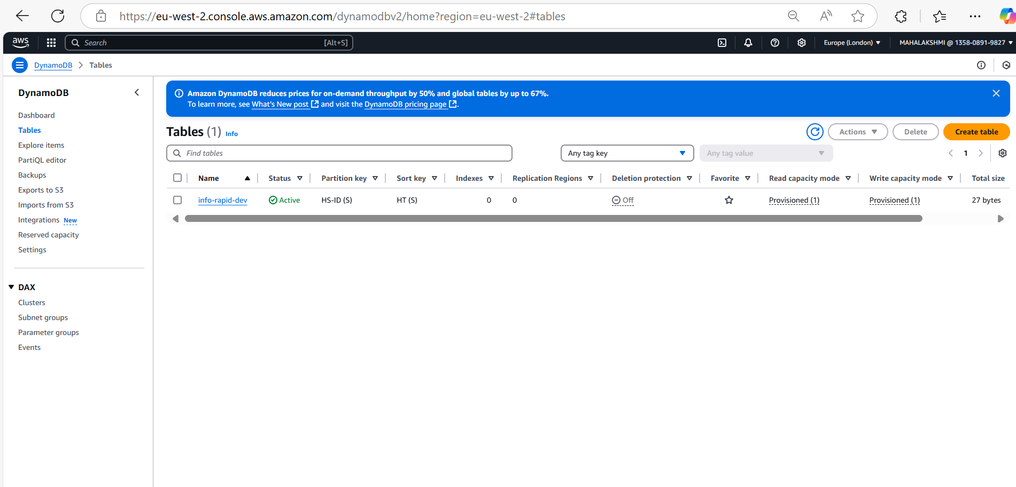

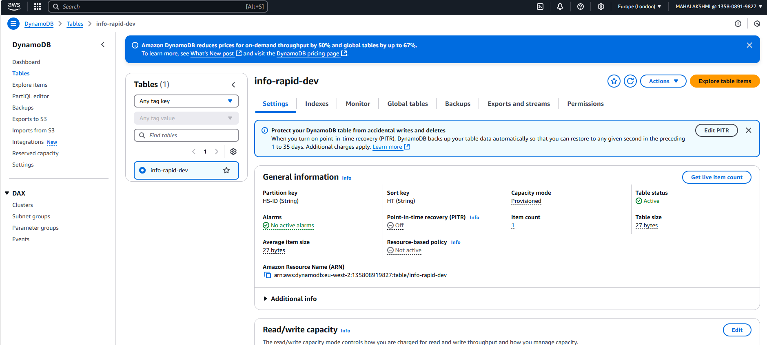

*Click on the “view items” to see the items. In that we get “scan or query” option.*

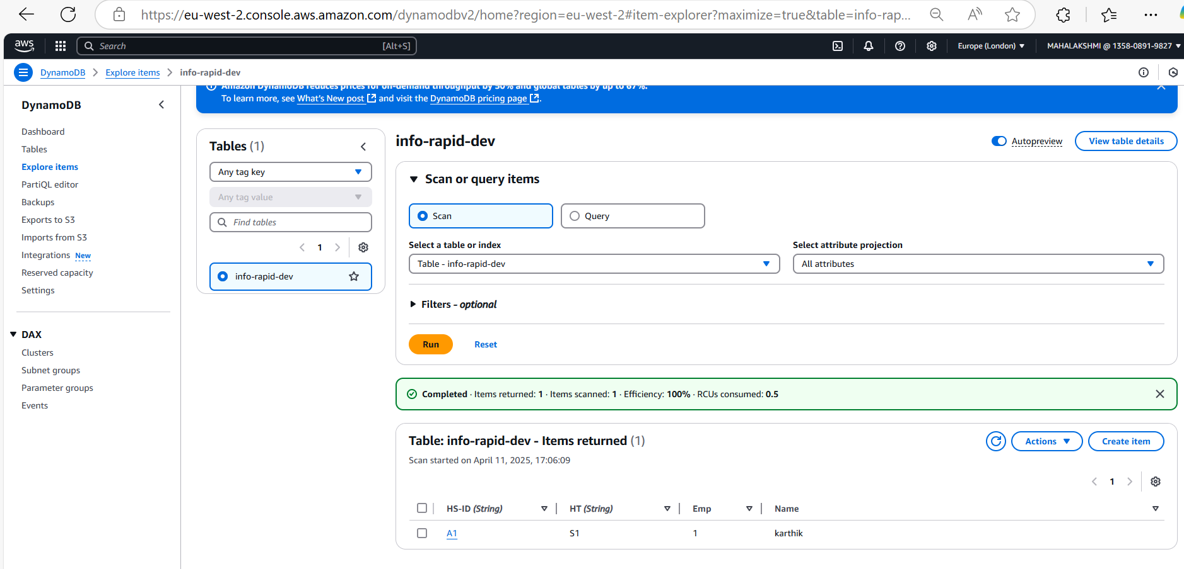

*Filters option is applied in the client side and not in the server side*

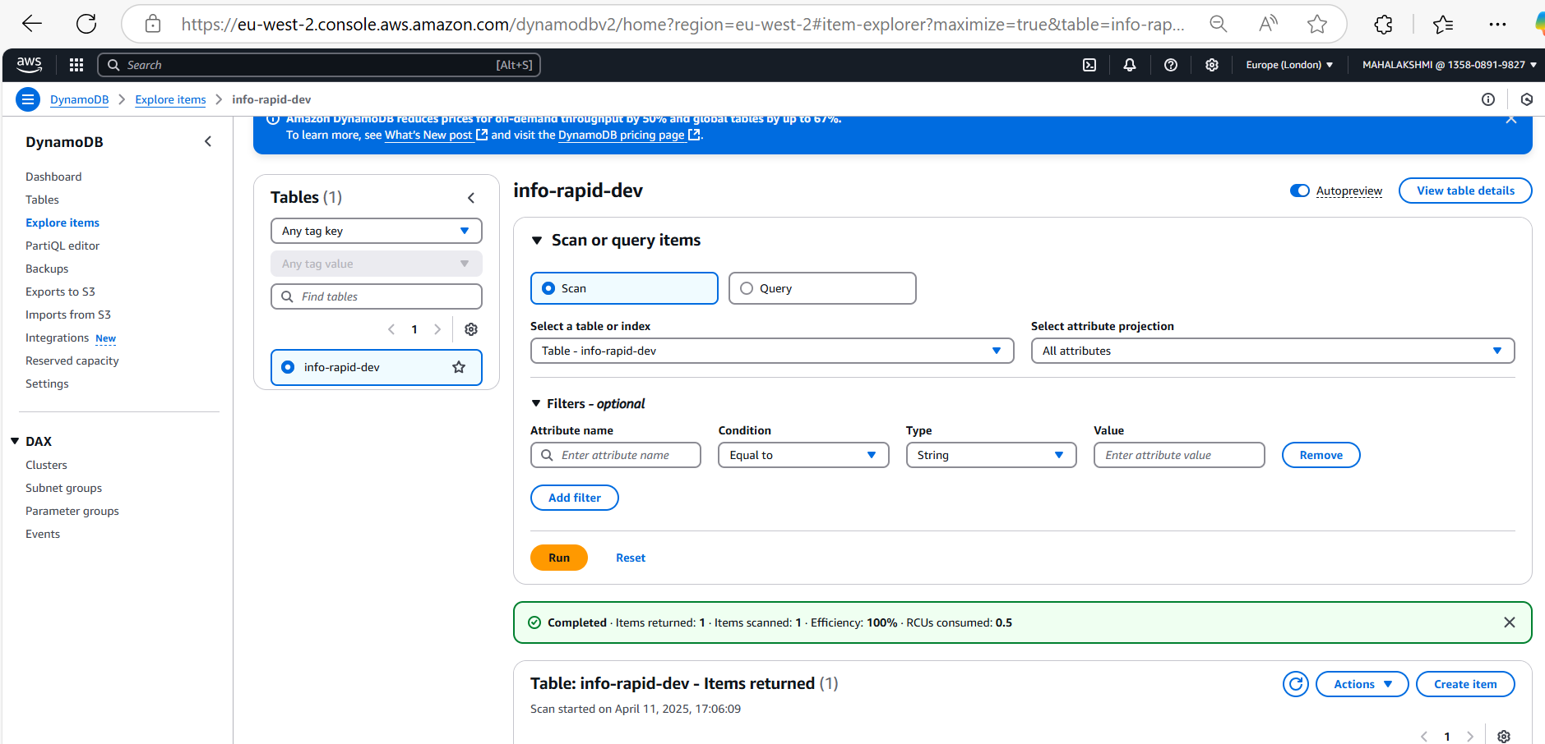

*Now on clicking the “Create item”, we could create an item or row.*

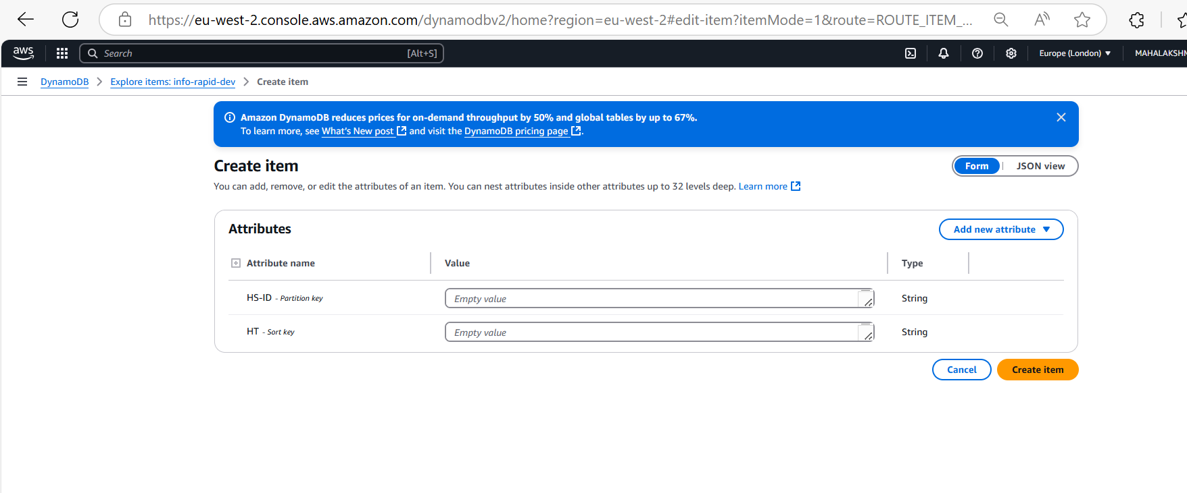

*Note: In dynamoDB we can add attributes at any time, in that case for the records which doesn’t have value(old / new record) for that field, it will show null automatically. In dynamoDB we can’t add constraints that the particular table can’t be null.*

***Hash + Range combination:***

*In this case, the uniqueness has to be combination of the “user_id” and “post_ts”. We can sort the data based on the “Range” key*

***Query: In case of query, we should enter the hash key for the partition key and the sort(range) key for sorting.***

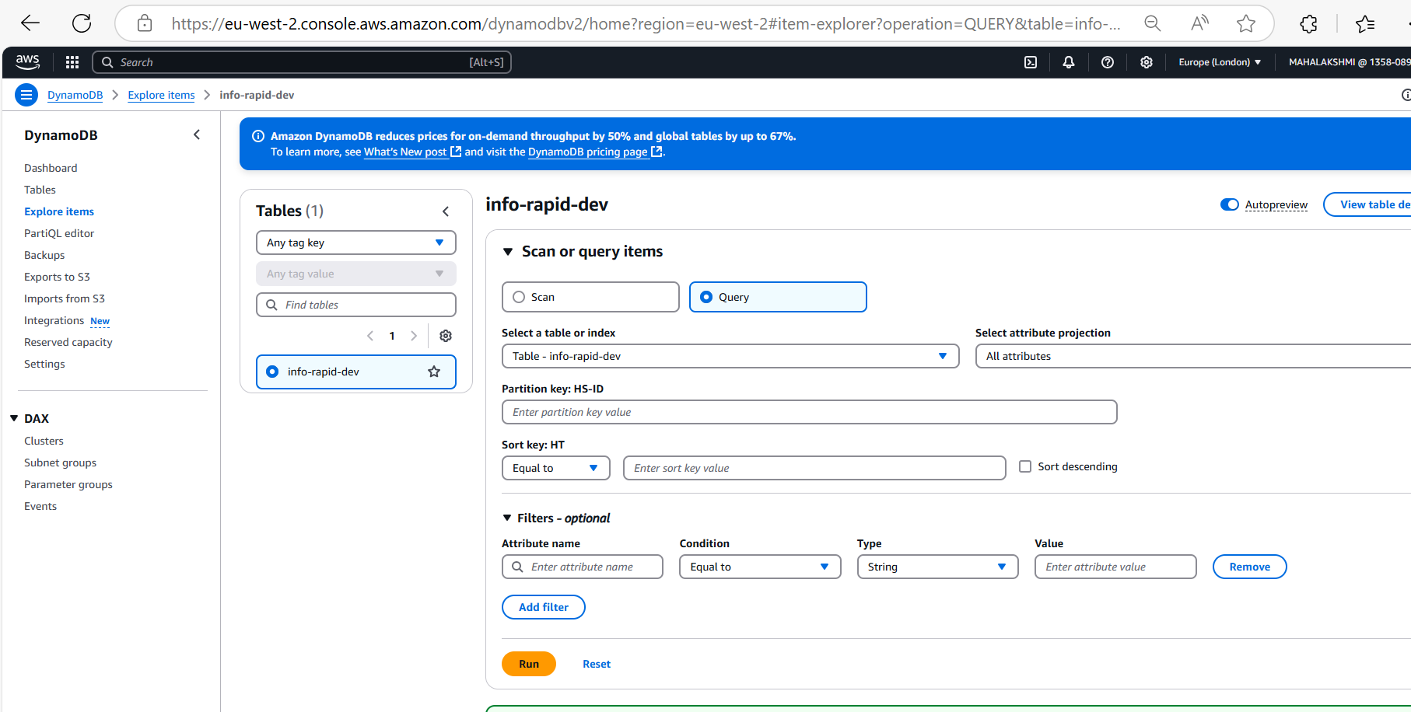

**DynamoDB Basic Operations:**

*“ProjectionExpression” can be retrieve only specific attributes, as well as “FilterExpression” is for the server side.*

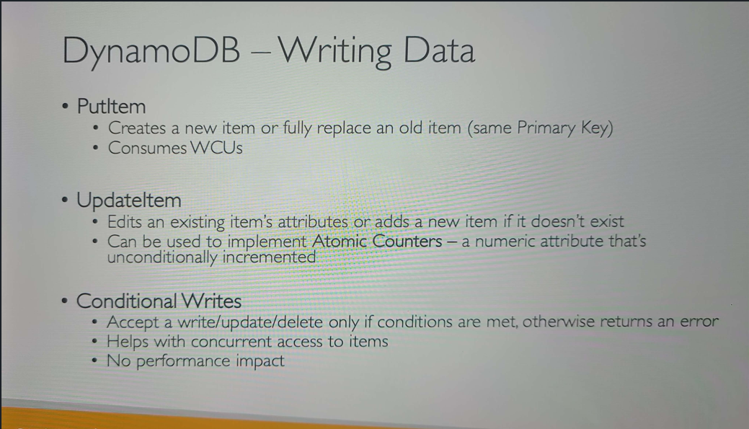

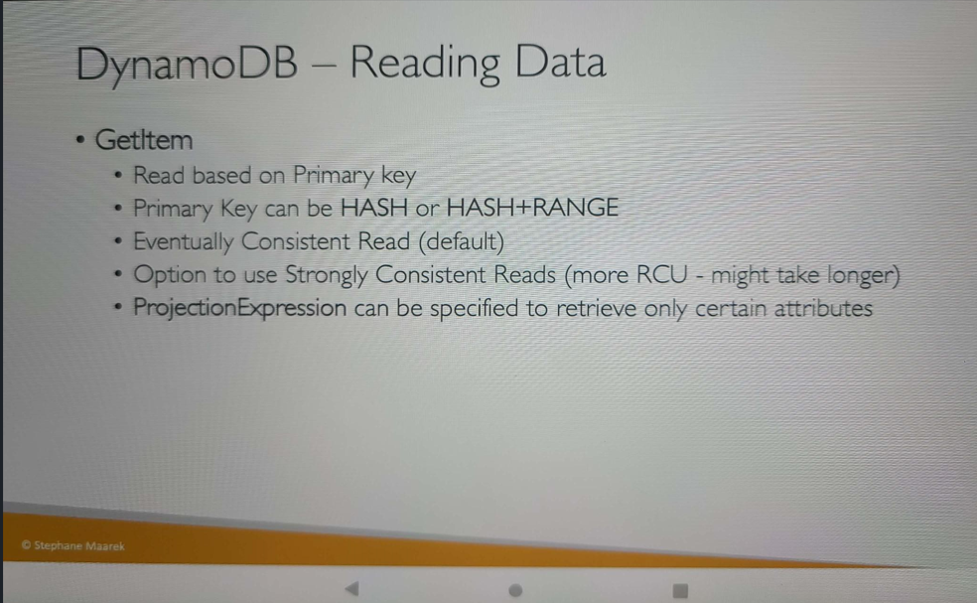

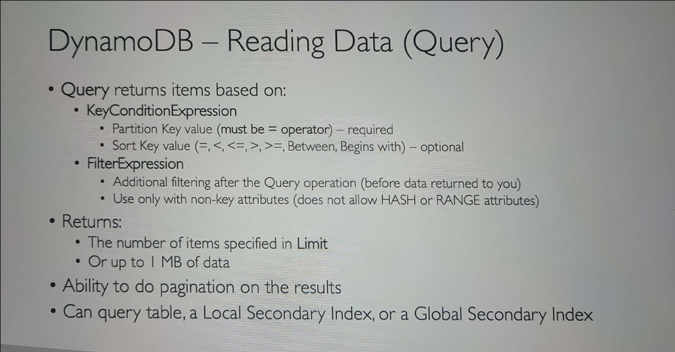

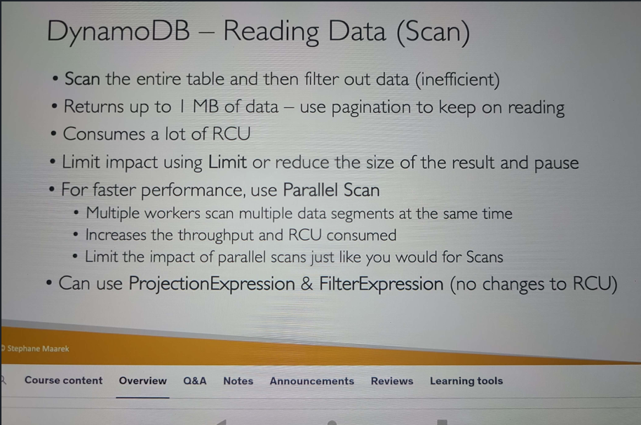

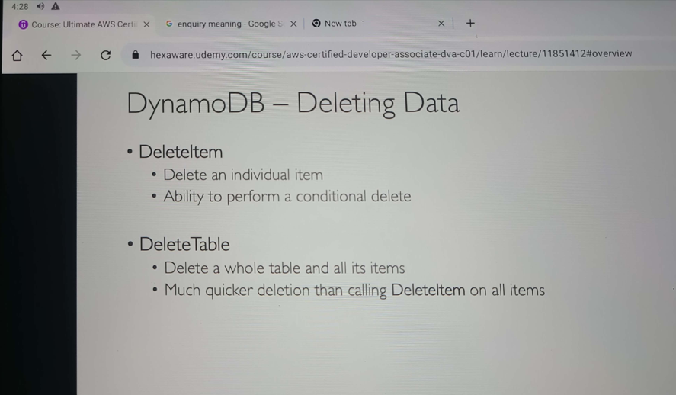

*In DyanmoDB we can use PartiQL, that’s we can use SQL query to insert, update and delete. Can be done at multiple tables but can’t perform join.*

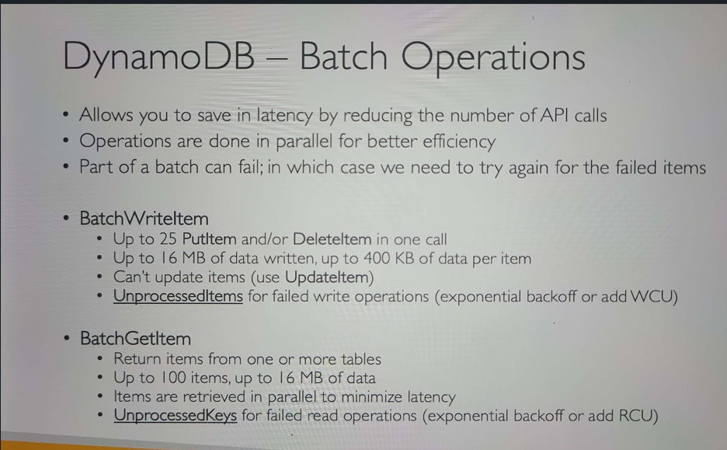

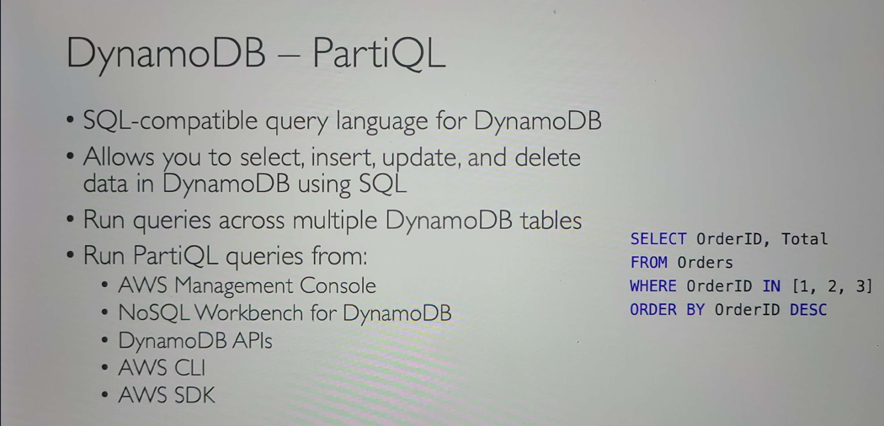

***Conditional Writes:***

*In the below example, the Price will be reduced by 650 to 500 (Price - discount) for the first time when the query is executed. Next time onwards when we run the same query the price will not be updated as the price now is not more than 500.*

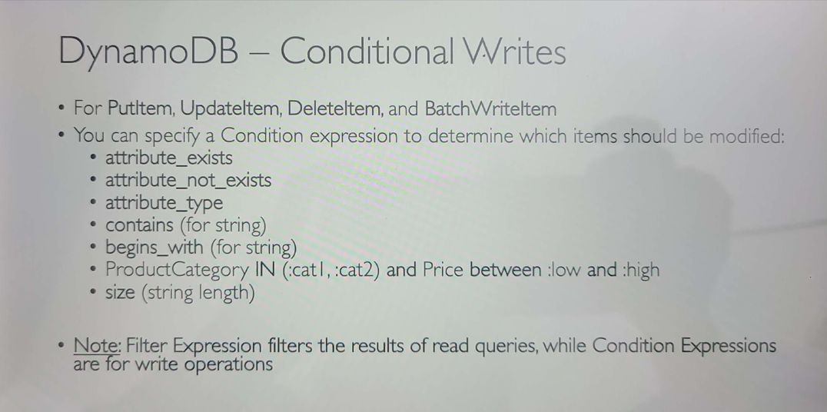

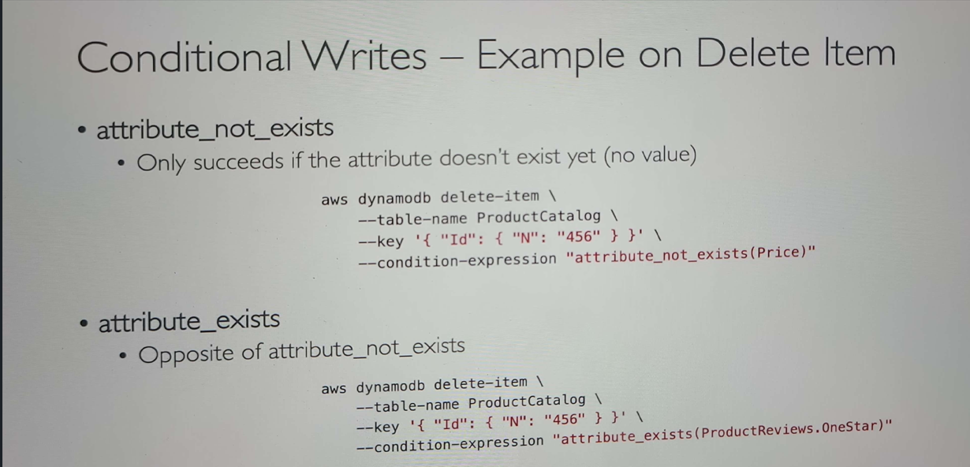

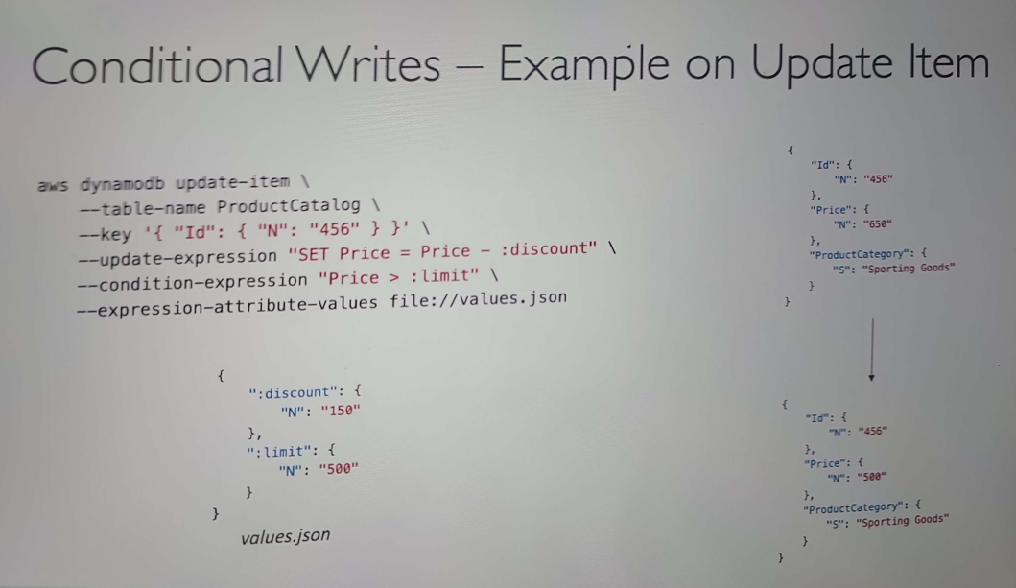

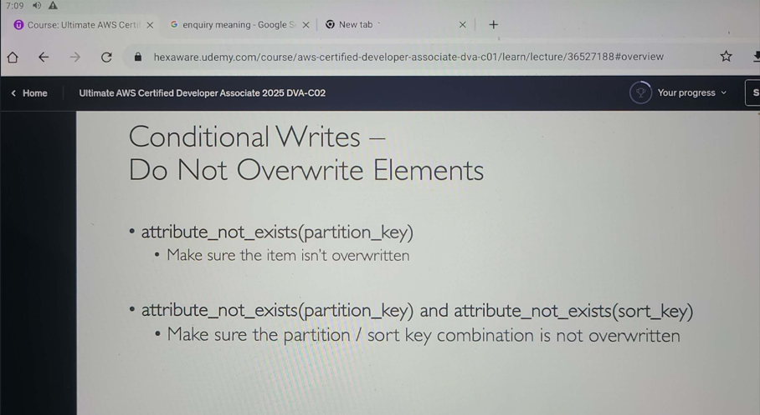

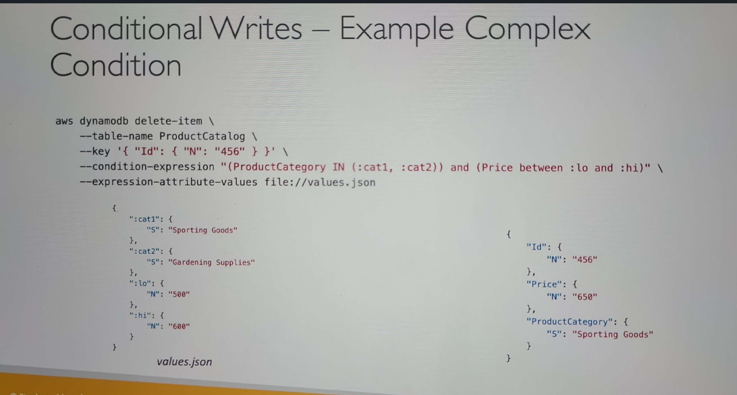

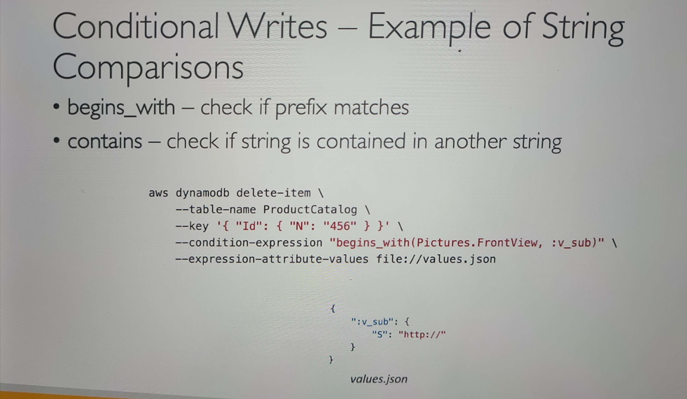

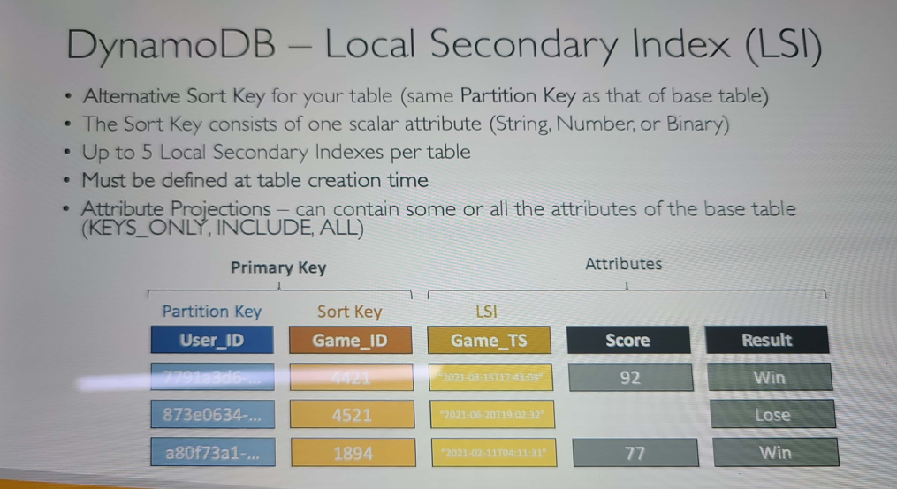

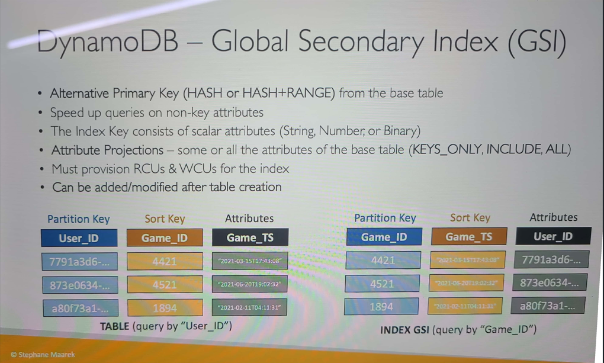

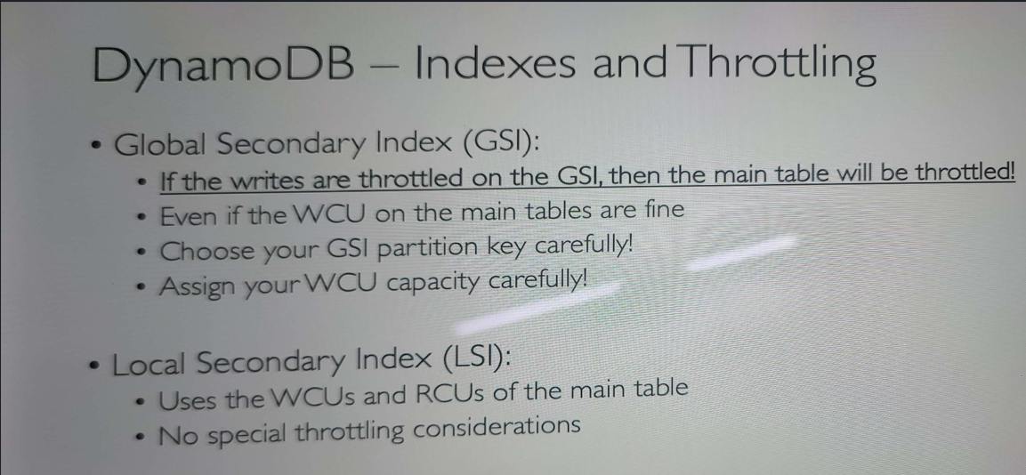

***Example:***

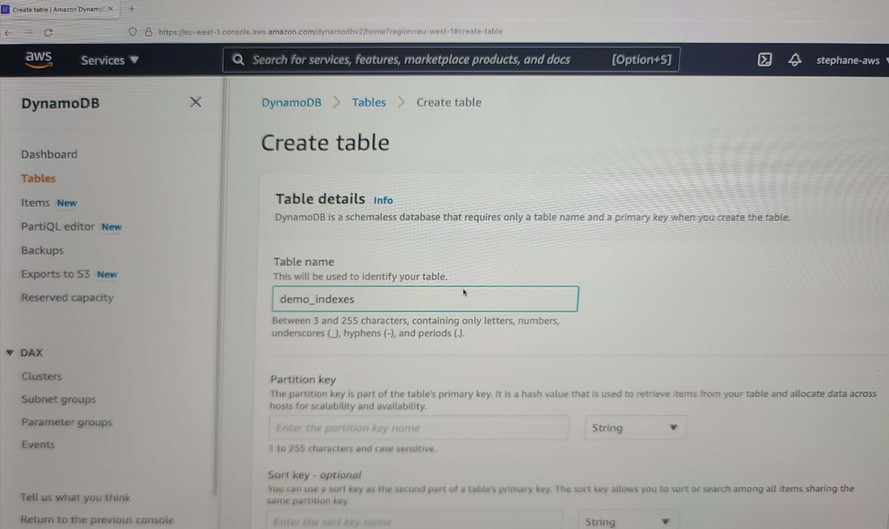

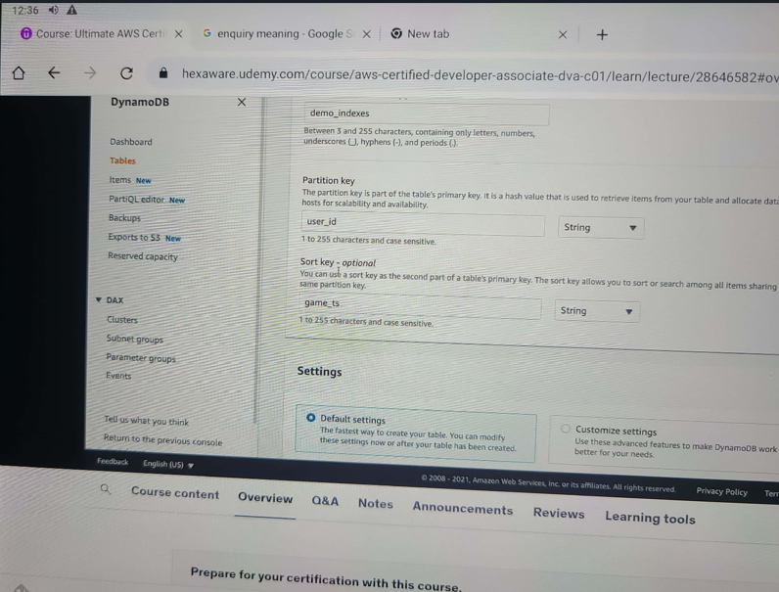

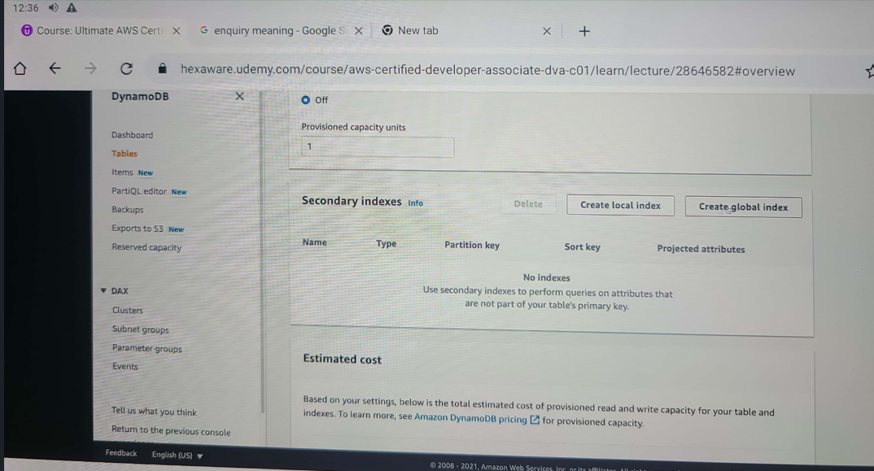

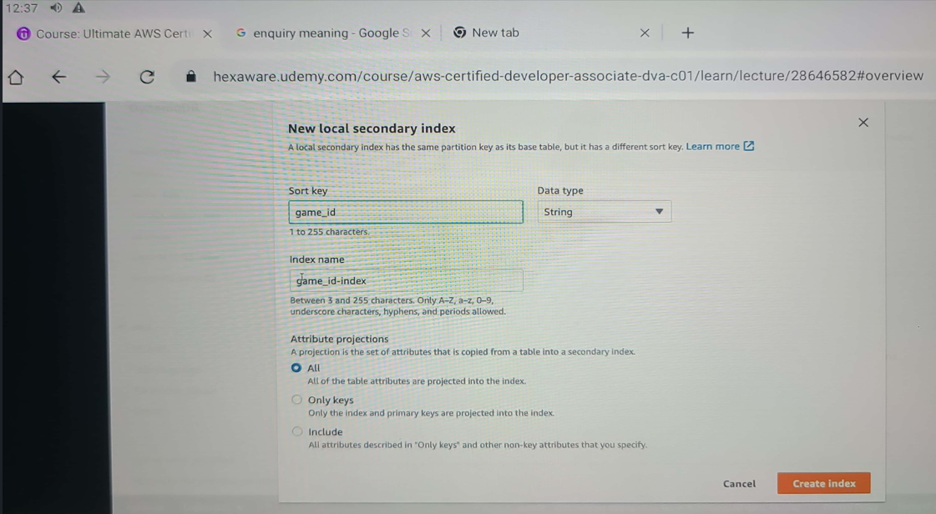

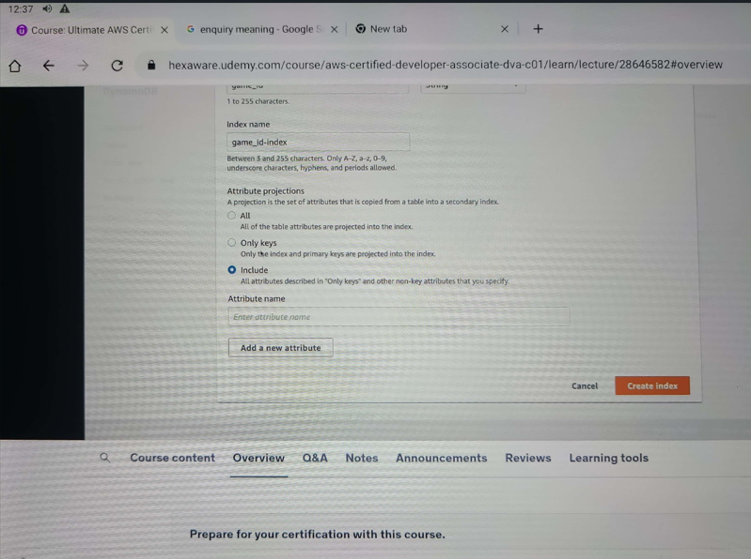

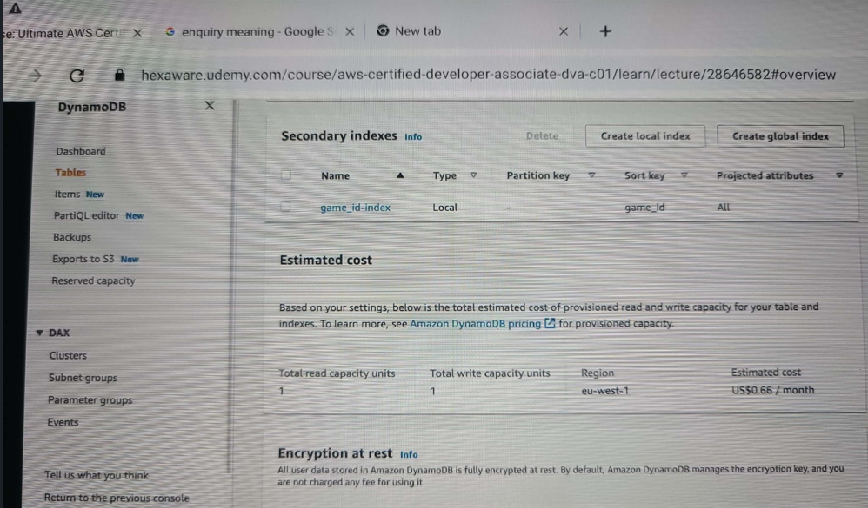

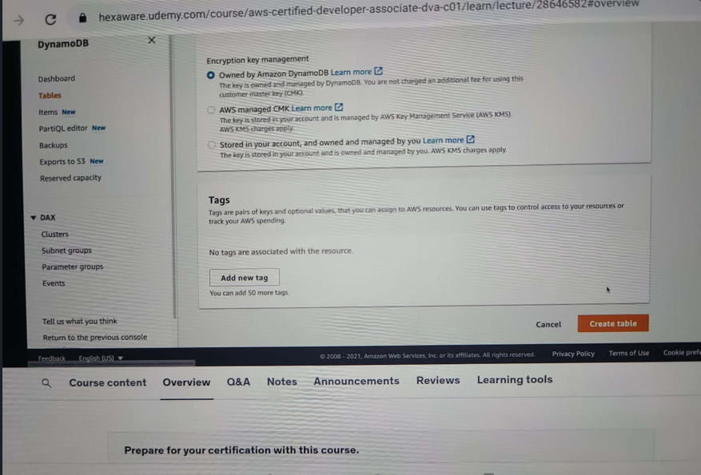

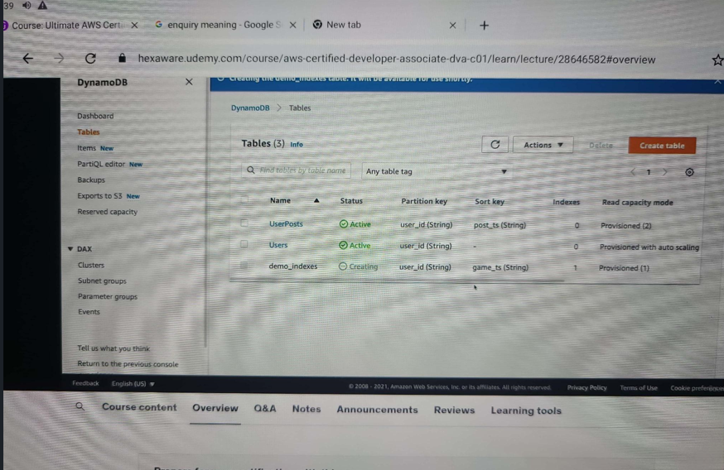

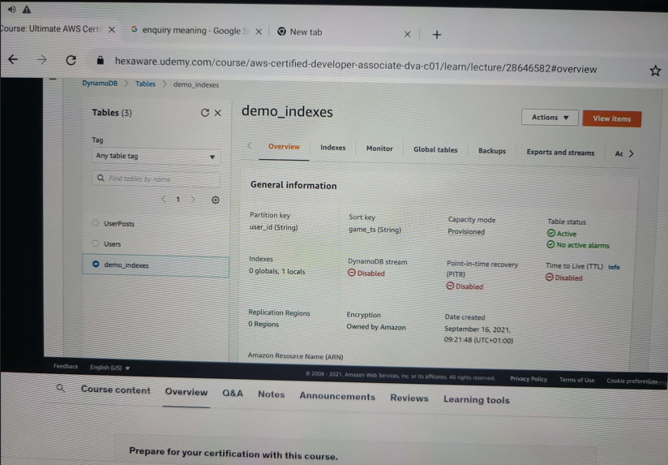

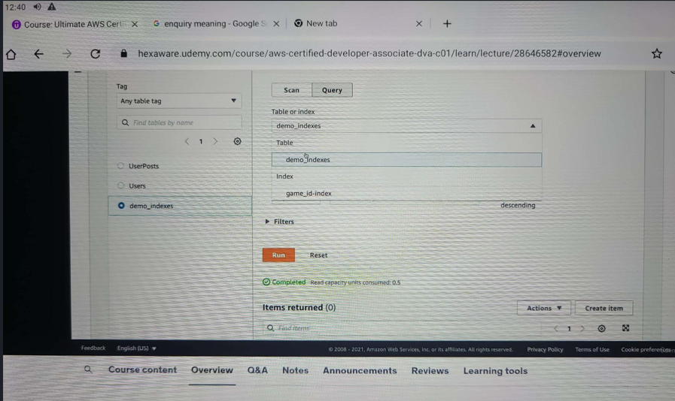

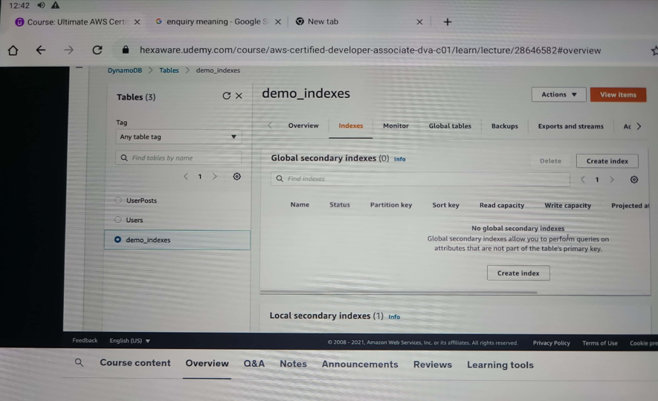

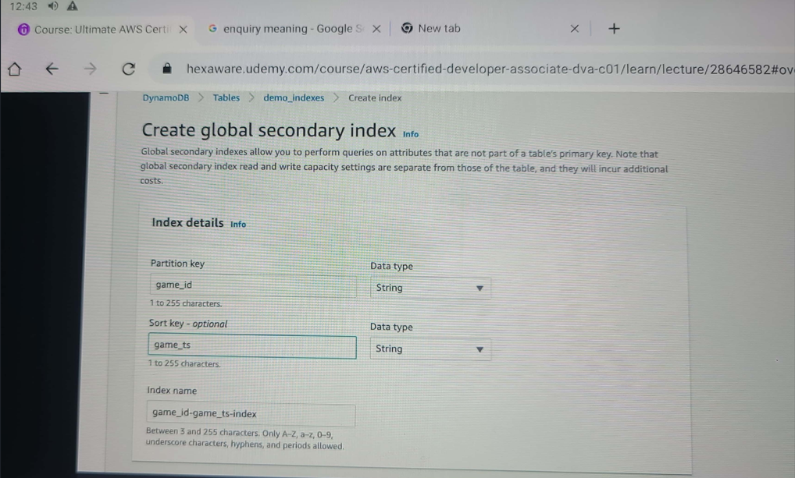

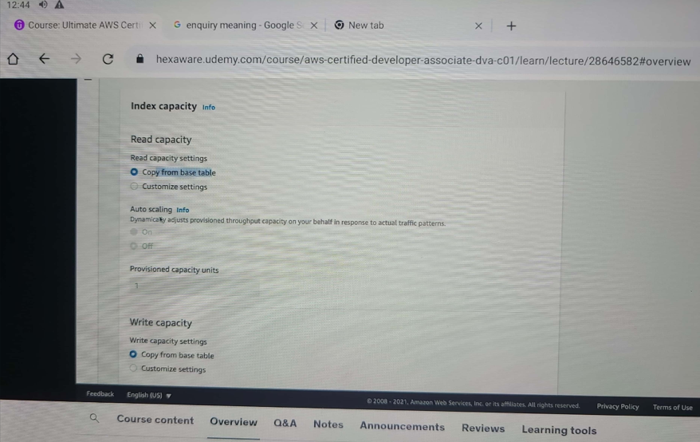

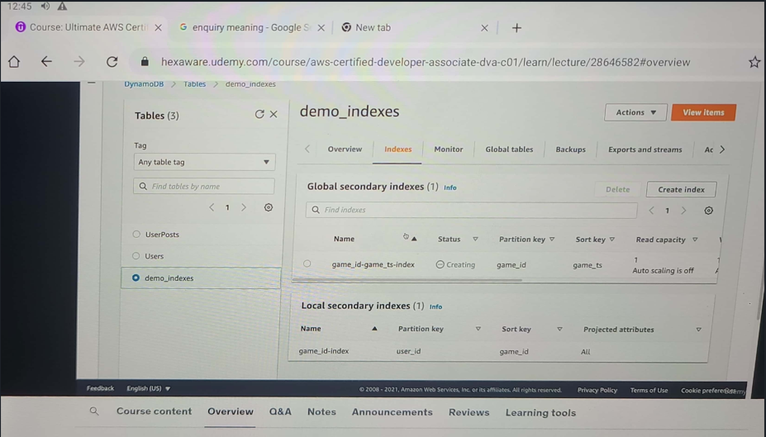

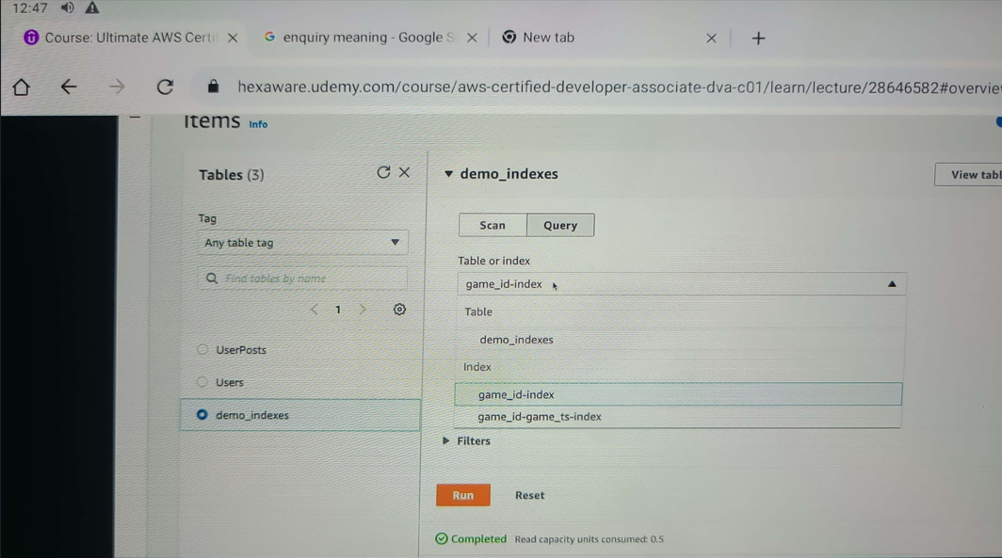

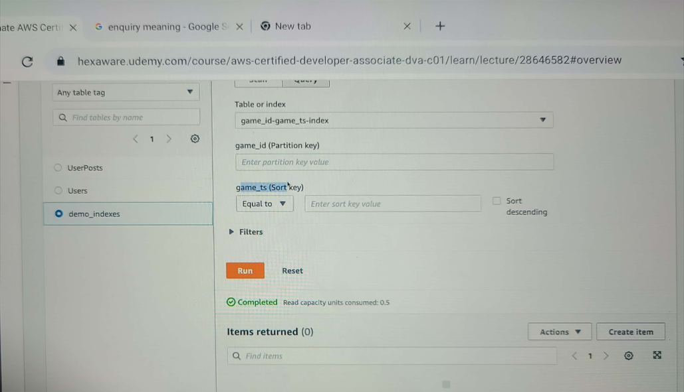

***DynamoDB: (PartiQL)***

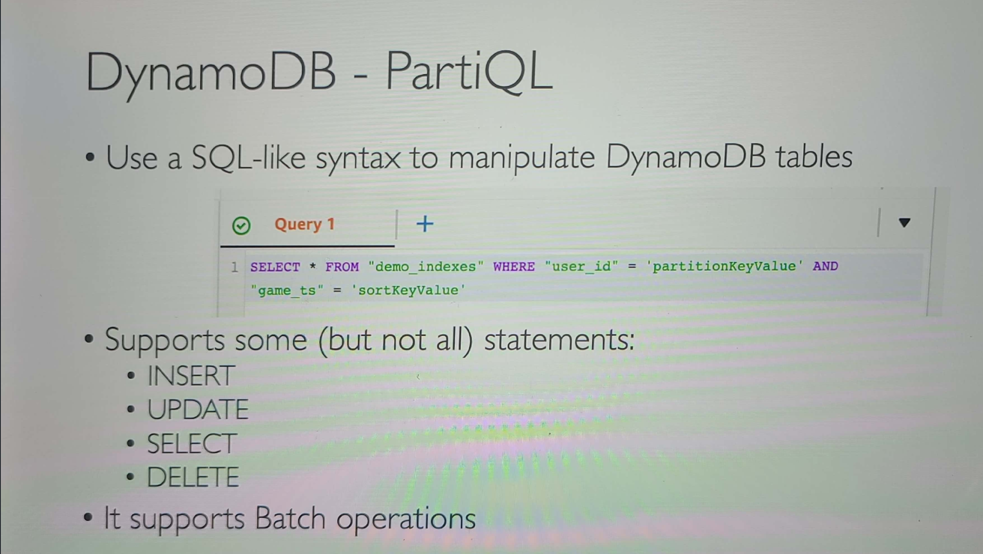

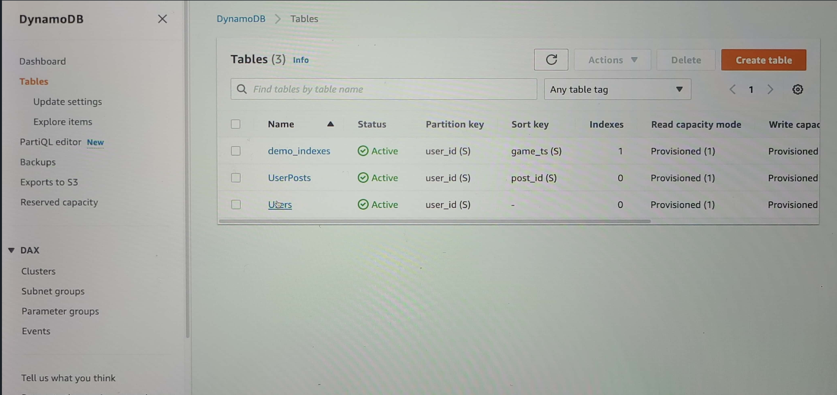

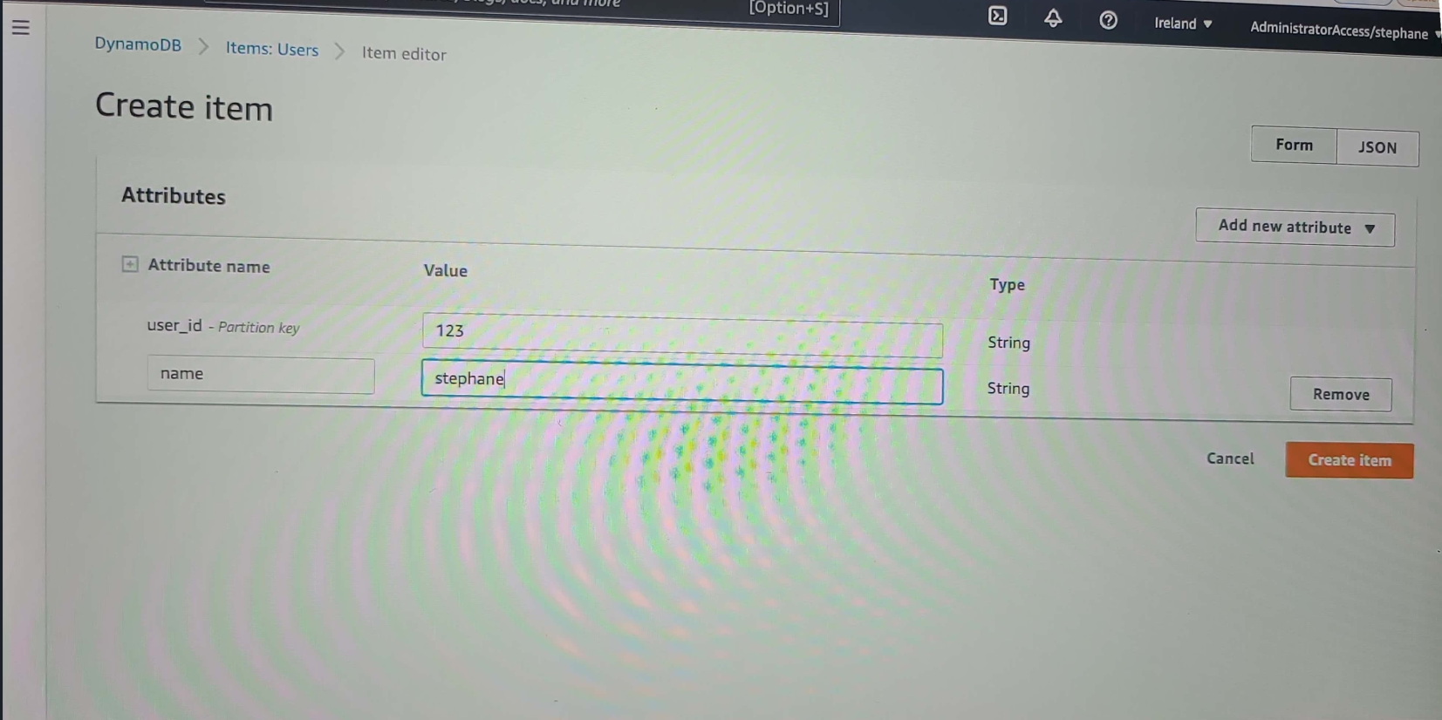

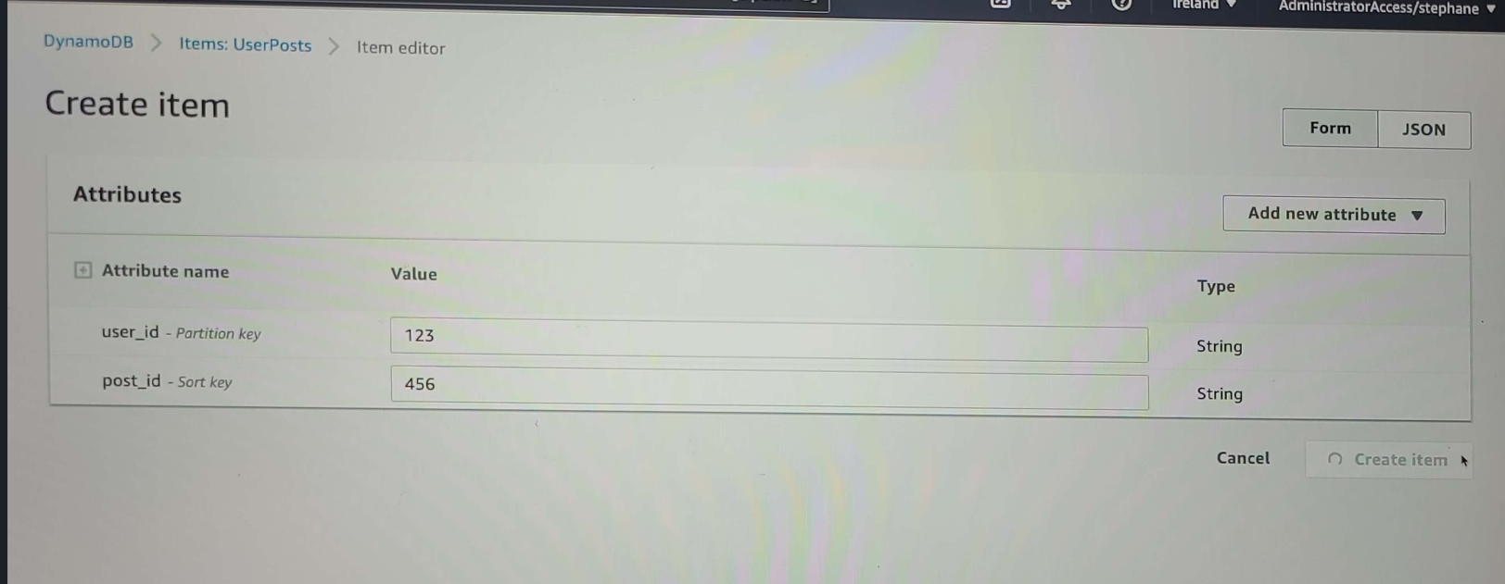

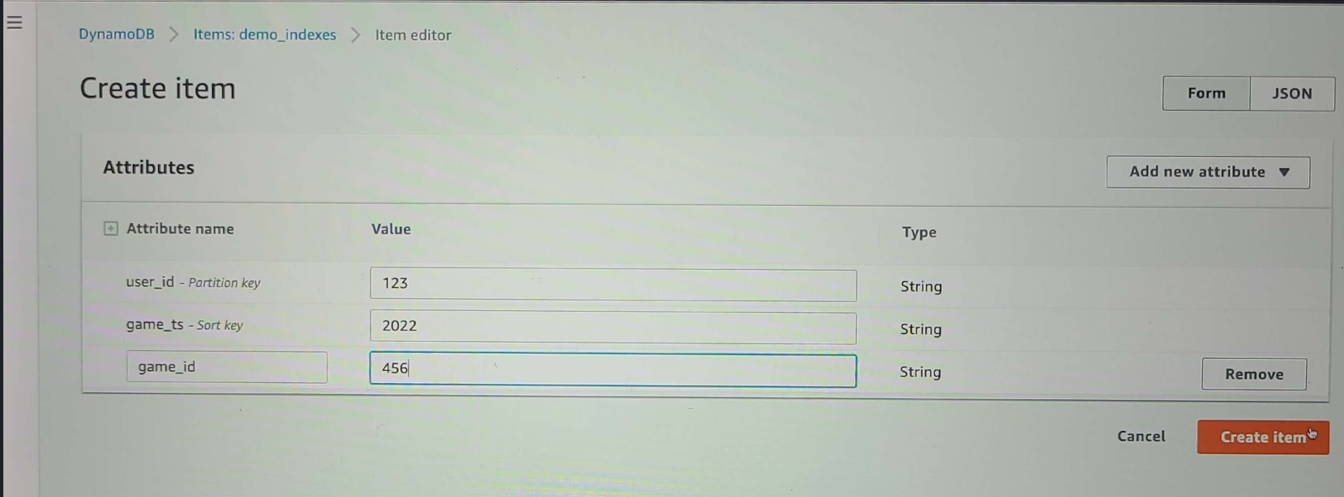

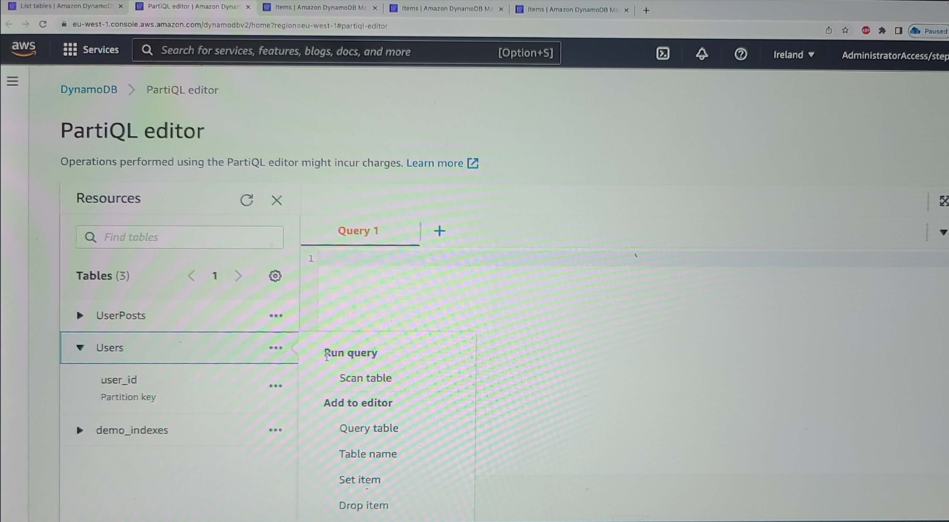

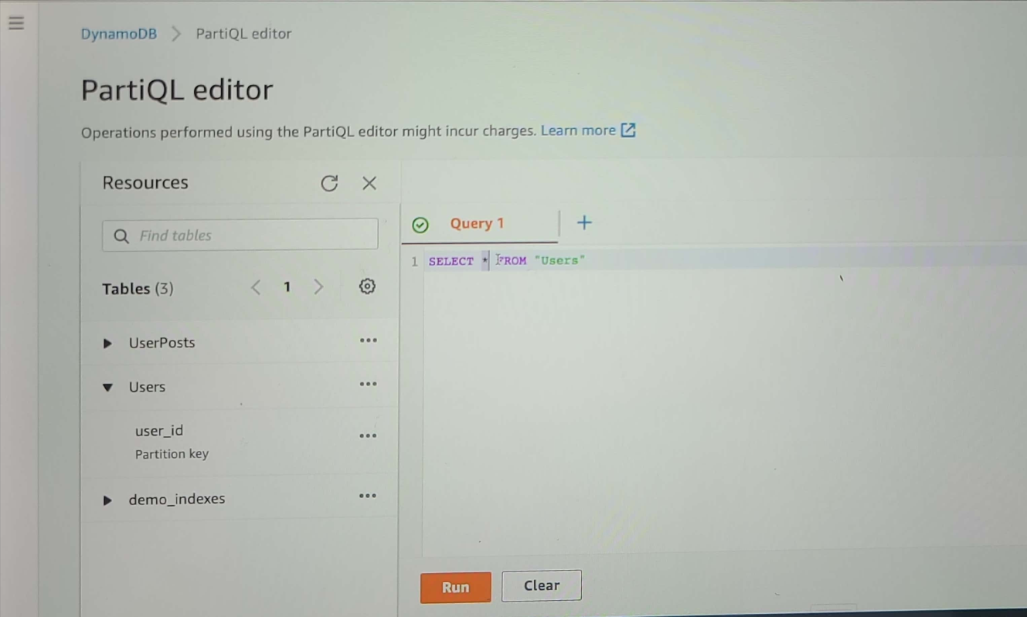

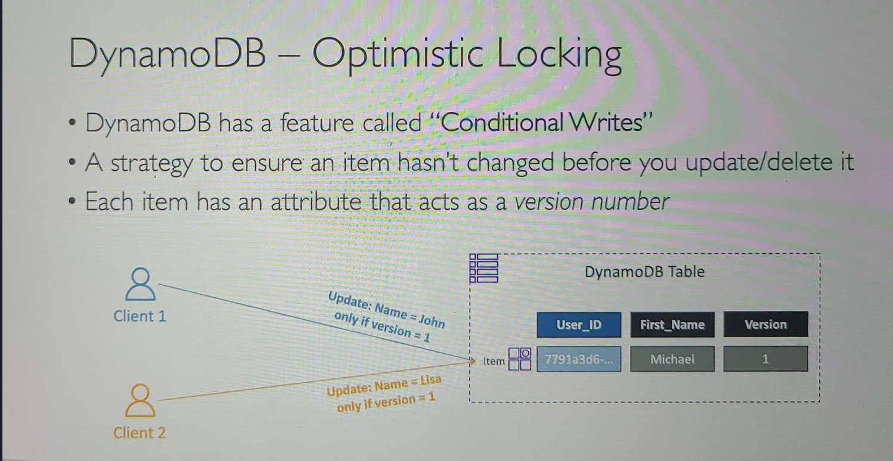

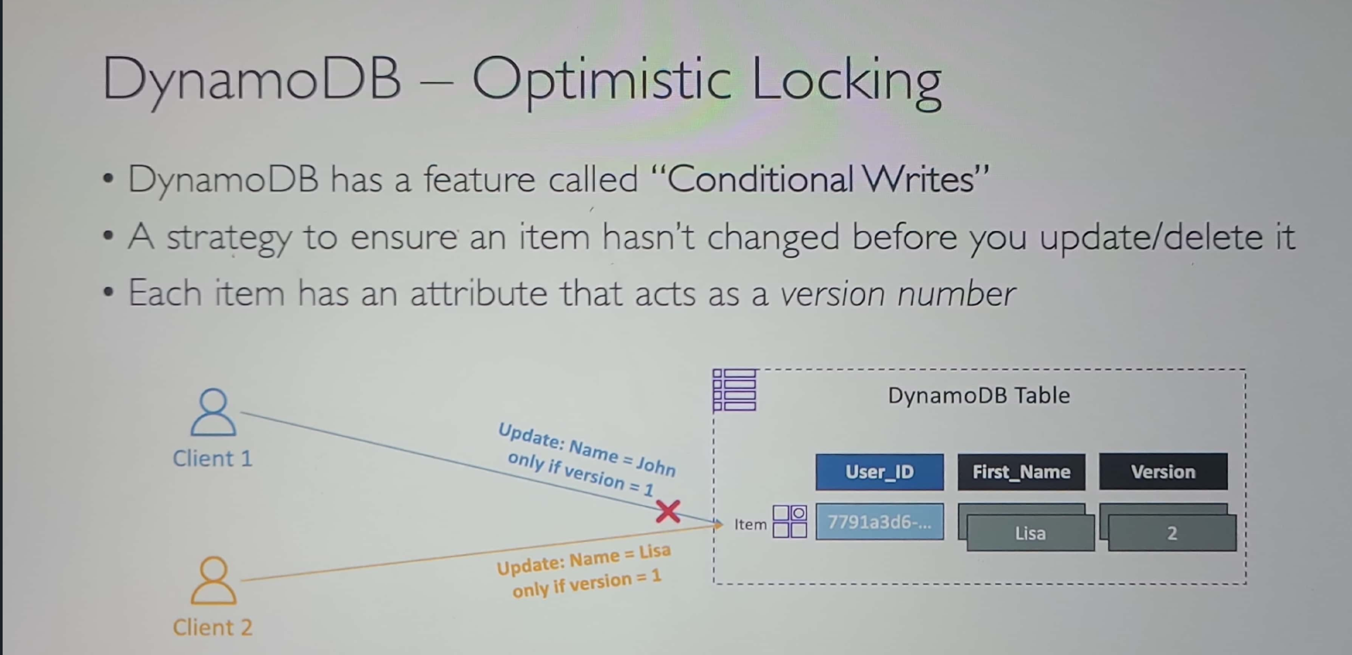

***On selecting the “PartiQL editor”, the following screen is displayed with the tables available in that region.***

On clicking the “…” dots at the right end of table, the following options are displayed. On selecting “Scan table”, the select query is generated for the table

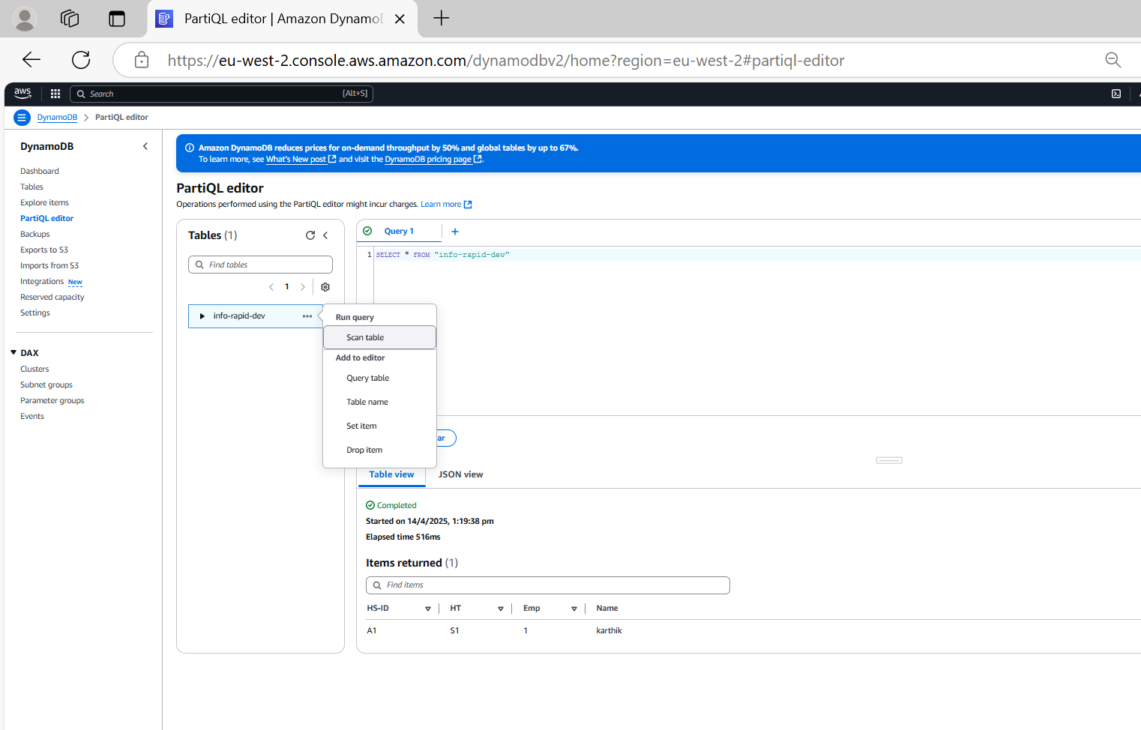

***On clicking the “Run” button , the query is executed and results are displayed***

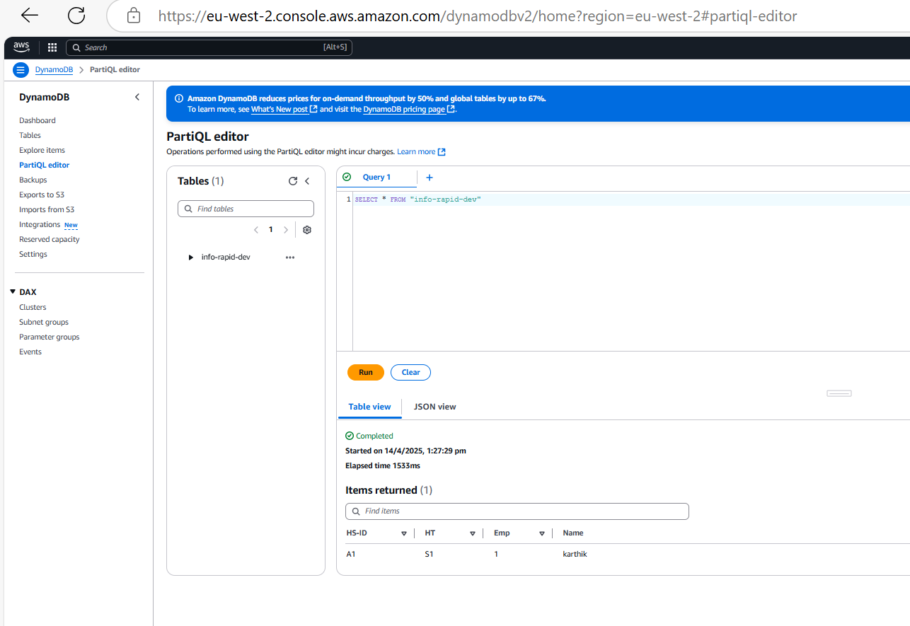

***We can get the Json view by clicking the “JSON view” tab***

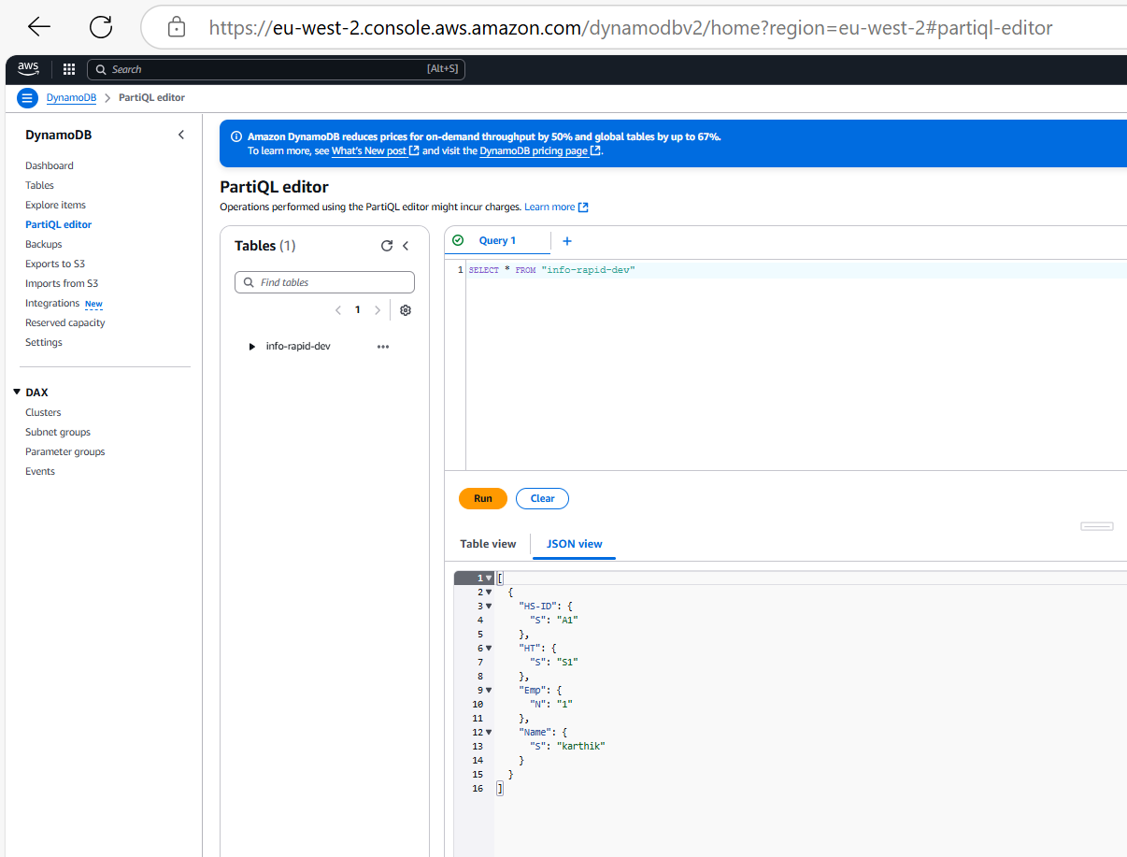

***Query table option:***

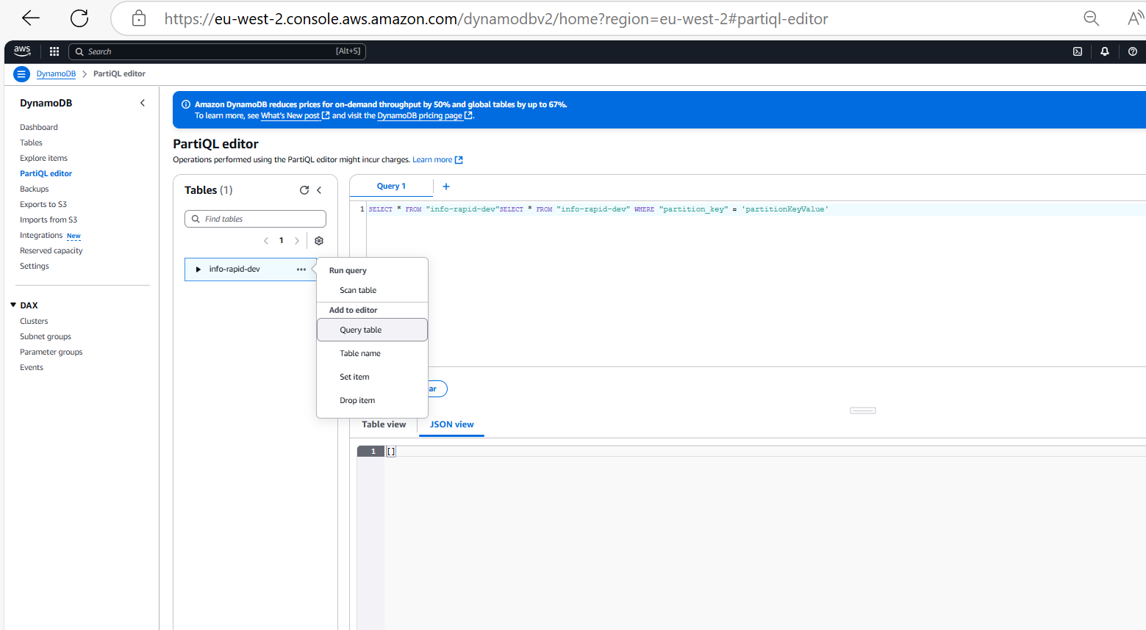

***Since no records are matching, empty array is generated***

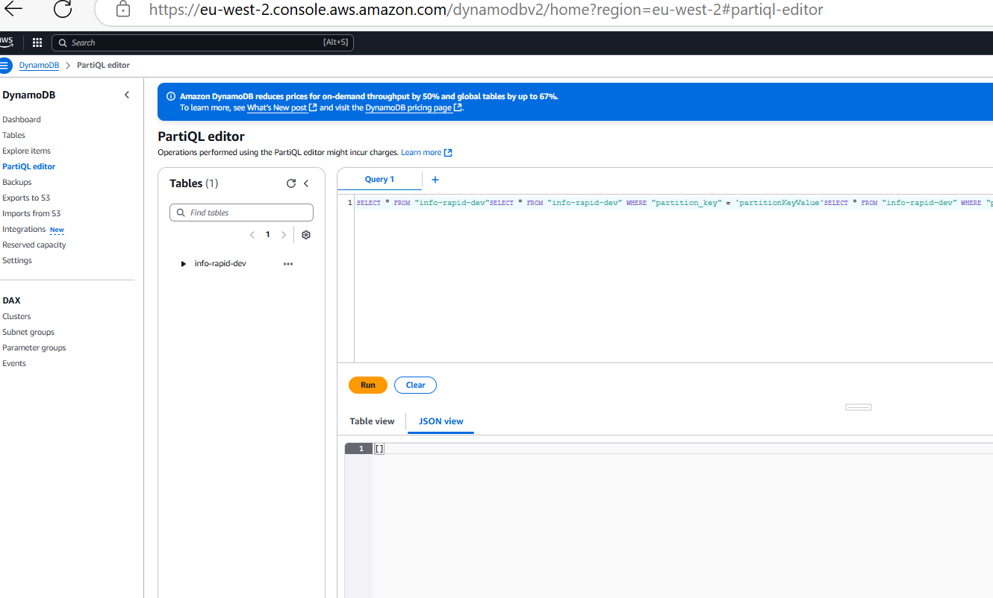

***On selecting Drop Item, delete query is generated***

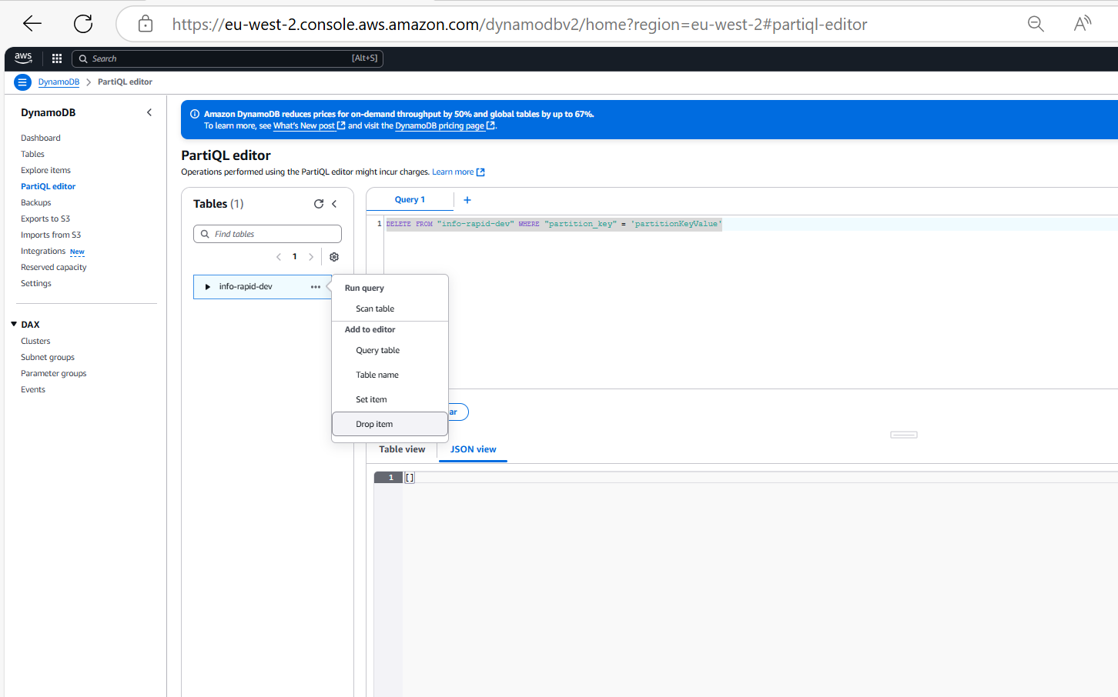

***DynamoDB DAX(Accelerator)***

This one helps to solve the hot keys problem(ie… reading the same record multiple times) which otherwise causes the throttle problem

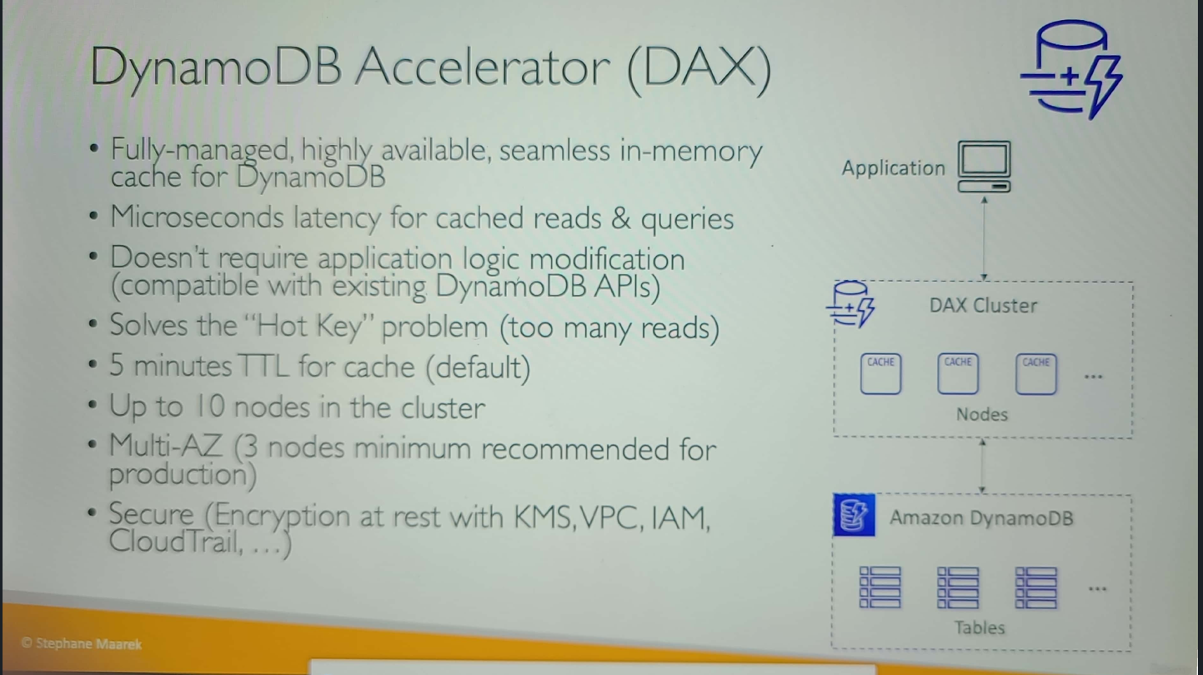

***DynamoDB Accelerator(DAX) vs ElasticCache:***

It is always best to use both in combination for the application

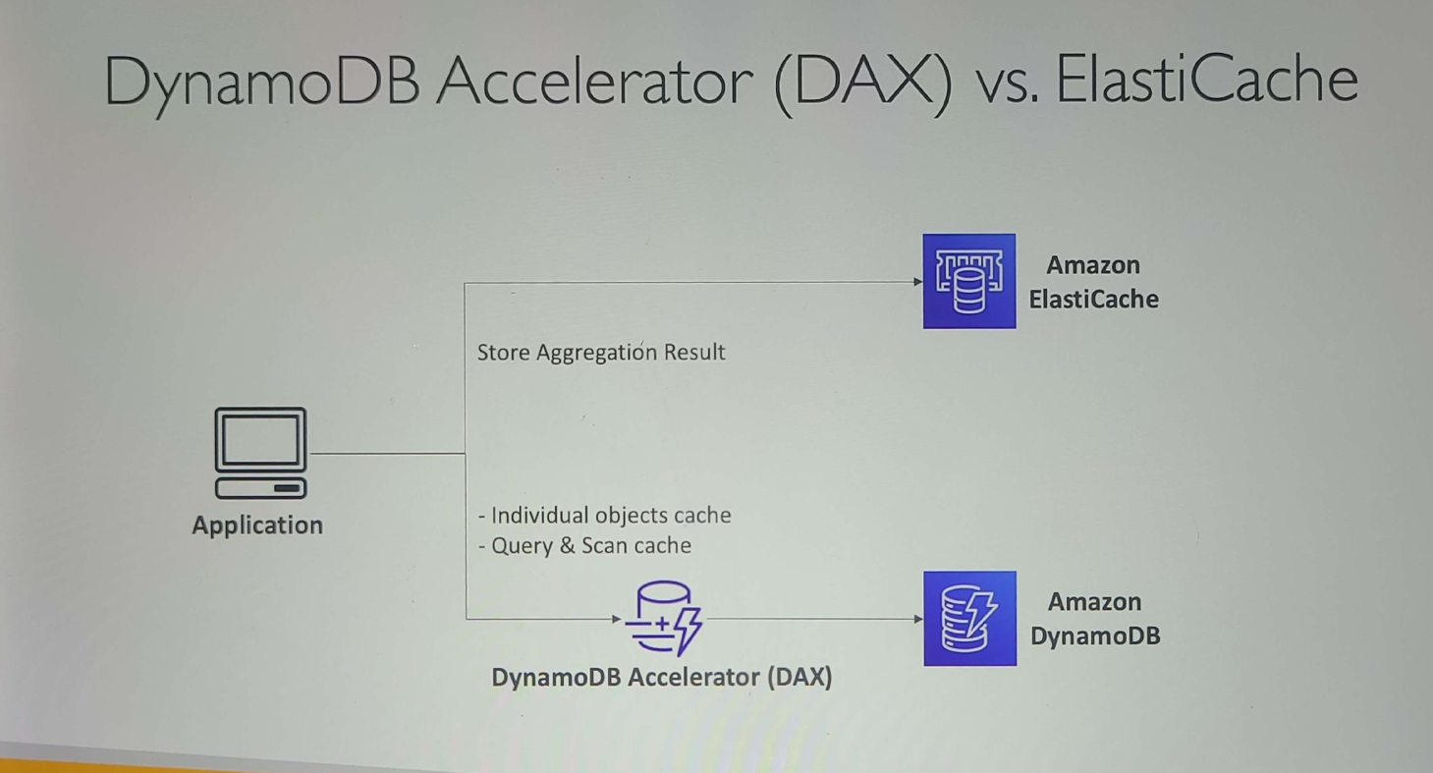

***Creation DAX Cluster:***

***On clicking the “Cluster” in DAX we can create the DAX Cluster***

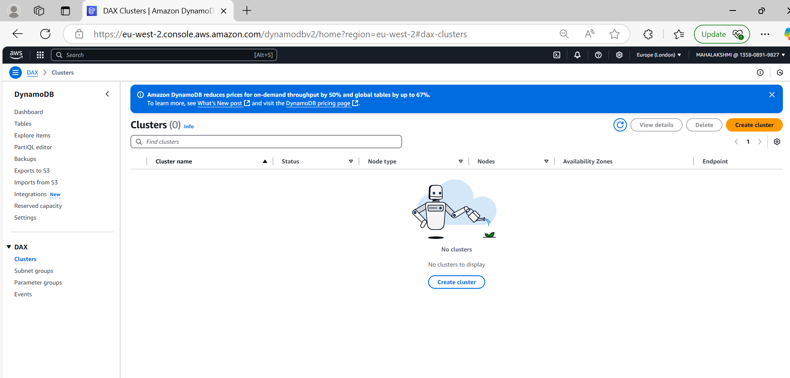

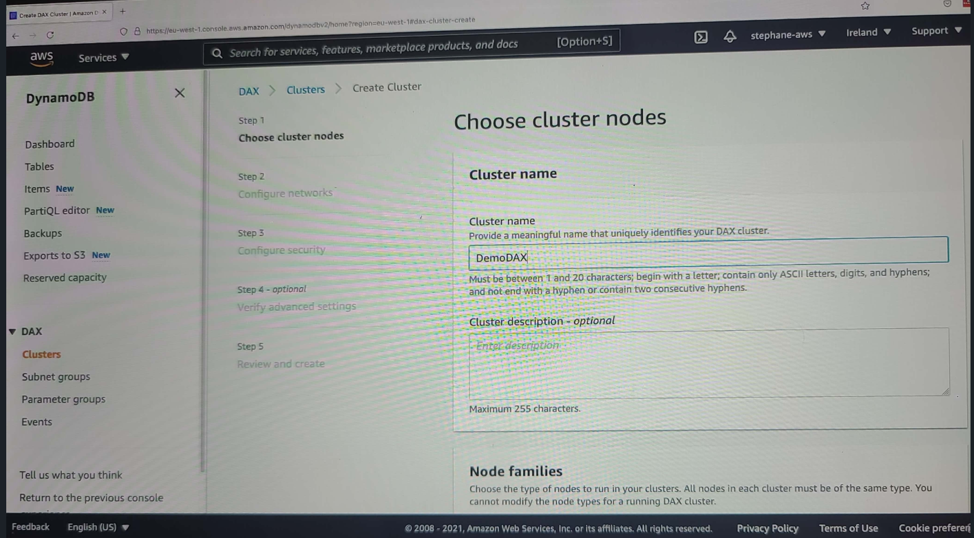

***Delete Cluster:***

***DynamoDB Streams***

*In order to access the DynamoDB streams we can use KCL Client App or Lambda, rest other are managed by AWS. (ie)Processing Layer alone can be used by us to access the streams*